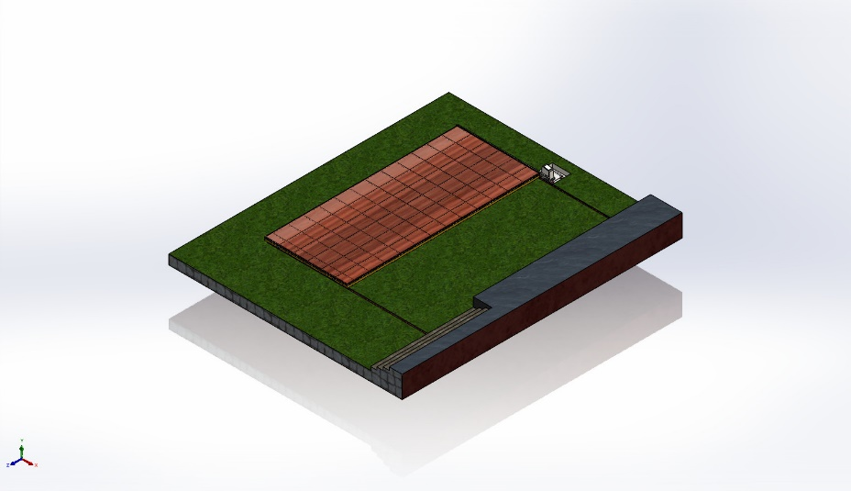
  Simulation of OPEN VIEW
  Date: Saturday, June 21, 2025
  Designer: VIJAY WAGHE
  Study name: Static 1
  Analysis type: Static
  Table of Contents
  Description 1
  Assumptions 2
  Model Information 3
  Study Properties 44
  Units 44
  Material Properties 45
  Loads and Fixtures 48
  Connector Definitions 48
  Interaction Information 49
  Mesh information 50
  Sensor Details 51
  Resultant Forces 51
  Beams 51
  Study Results 51
  Conclusion 51

Description
No Data

Assumptions

Model Information

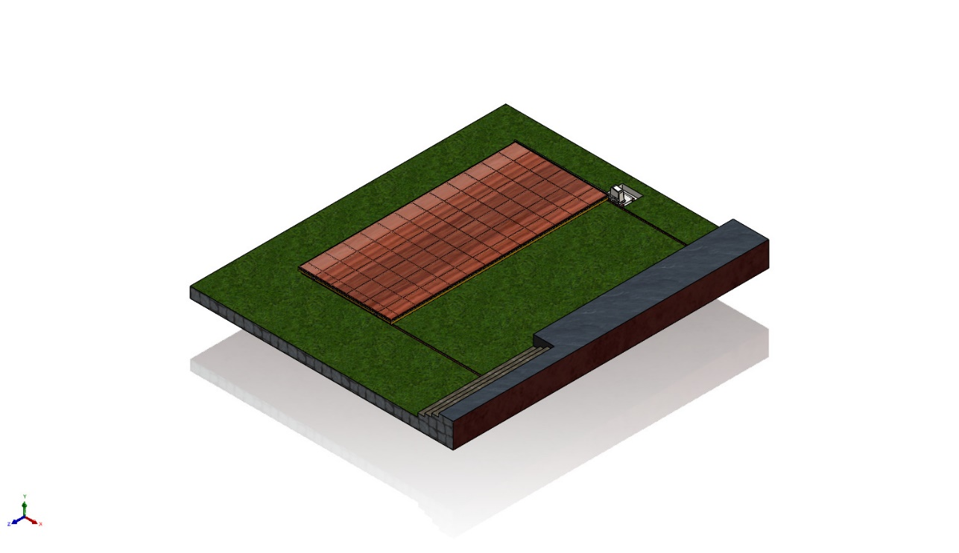
Model name: OPEN VIEW
Current Configuration: Default
Solid Bodies
Document Name and Reference | Treated As | Volumetric Properties | Document Path/Date Modified
Cut-Extrude11  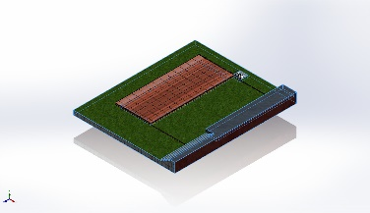 | Solid Body | Mass:165,673 kg  Volume:20.7092 m^3  Density:8,000 kg/m^3  Weight:1.6236e+06 N | D:\SWIMMING POOL ENCLOSER'S\SWIMMING POOL DECK\3D MODEL\CIVIL BASE.SLDPRT  Jun 19 11:22:07 2025
Boss-Extrude4  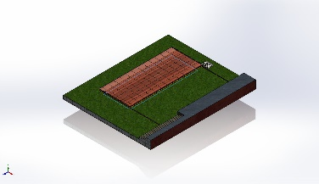 | Solid Body | Mass:104.635 kg  Volume:0.0130793 m^3  Density:8,000 kg/m^3  Weight:1,025.42 N | D:\SWIMMING POOL ENCLOSER'S\SWIMMING POOL DECK\3D MODEL\CIVIL BASE.SLDPRT  Jun 19 11:22:07 2025
Boss-Extrude1  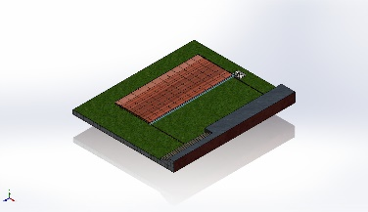 | Solid Body | Mass:13.3898 kg  Volume:0.00167373 m^3  Density:8,000 kg/m^3  Weight:131.22 N | D:\SWIMMING POOL ENCLOSER'S\SWIMMING POOL DECK\3D MODEL\CLOSING SHEET 2.SLDPRT  Jun 11 10:05:53 2025
Boss-Extrude1  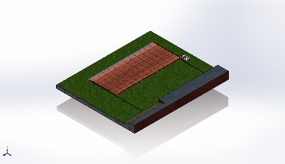 | Solid Body | Mass:13.3898 kg  Volume:0.00167373 m^3  Density:8,000 kg/m^3  Weight:131.22 N | D:\SWIMMING POOL ENCLOSER'S\SWIMMING POOL DECK\3D MODEL\CLOSING SHEET 2.SLDPRT  Jun 11 10:05:53 2025
Thread1 | Solid Body | Mass:0.0176869 kg  Volume:2.21086e-06 m^3  Density:7,999.99 kg/m^3  Weight:0.173331 N | D:\SWIMMING POOL ENCLOSER'S\SWIMMING POOL DECK\3D MODEL\NUT.SLDPRT  Jun 21 09:28:19 2025
Boss-Extrude1 | Solid Body | Mass:0.0016085 kg  Volume:2.01062e-07 m^3  Density:8,000 kg/m^3  Weight:0.0157633 N | D:\SWIMMING POOL ENCLOSER'S\SWIMMING POOL DECK\3D MODEL\WASHER.SLDPRT  Jun 21 09:28:19 2025
Boss-Extrude1 | Solid Body | Mass:0.0016085 kg  Volume:2.01062e-07 m^3  Density:8,000 kg/m^3  Weight:0.0157633 N | D:\SWIMMING POOL ENCLOSER'S\SWIMMING POOL DECK\3D MODEL\WASHER.SLDPRT  Jun 21 09:28:19 2025
Thread3 | Solid Body | Mass:0.0715643 kg  Volume:8.94535e-06 m^3  Density:8,000.16 kg/m^3  Weight:0.70133 N | D:\SWIMMING POOL ENCLOSER'S\SWIMMING POOL DECK\3D MODEL\WHEEL AXLE.SLDPRT  Jun 21 09:28:19 2025
Cut-Extrude2 | Solid Body | Mass:0.561687 kg  Volume:7.02109e-05 m^3  Density:8,000 kg/m^3  Weight:5.50454 N | D:\SWIMMING POOL ENCLOSER'S\SWIMMING POOL DECK\3D MODEL\WHEEL.SLDPRT  Jun 21 09:28:19 2025
p BEARING, SINGLE-ROW RADIAL, OPEN, METRIC 6200 SERIES — 6201 — 12mm ID × 32mm OD × 10mm W.STEP<1>[8] | Solid Body | Mass:0.00109807 kg  Volume:1.37258e-07 m^3  Density:8,000 kg/m^3  Weight:0.010761 N | C:\Users\Vijay W\AppData\Local\Temp\swx11860\IC~~\p BEARING, SINGLE-ROW RADIAL, OPEN, METRIC 6200 SERIES — 6201 — 12mm ID × 32mm OD × 10mm W.step.SLDPRT  Jun 21 11:54:34 2025
p BEARING, SINGLE-ROW RADIAL, OPEN, METRIC 6200 SERIES — 6201 — 12mm ID × 32mm OD × 10mm W.STEP<1>[12] | Solid Body | Mass:0.00109807 kg  Volume:1.37258e-07 m^3  Density:8,000 kg/m^3  Weight:0.010761 N | C:\Users\Vijay W\AppData\Local\Temp\swx11860\IC~~\p BEARING, SINGLE-ROW RADIAL, OPEN, METRIC 6200 SERIES — 6201 — 12mm ID × 32mm OD × 10mm W.step.SLDPRT  Jun 21 11:54:34 2025
p BEARING, SINGLE-ROW RADIAL, OPEN, METRIC 6200 SERIES — 6201 — 12mm ID × 32mm OD × 10mm W.STEP<1>[1] | Solid Body | Mass:0.0214385 kg  Volume:2.67981e-06 m^3  Density:8,000 kg/m^3  Weight:0.210097 N | C:\Users\Vijay W\AppData\Local\Temp\swx11860\IC~~\p BEARING, SINGLE-ROW RADIAL, OPEN, METRIC 6200 SERIES — 6201 — 12mm ID × 32mm OD × 10mm W.step.SLDPRT  Jun 21 11:54:34 2025
p BEARING, SINGLE-ROW RADIAL, OPEN, METRIC 6200 SERIES — 6201 — 12mm ID × 32mm OD × 10mm W.STEP<1>[6] | Solid Body | Mass:0.0113587 kg  Volume:1.41984e-06 m^3  Density:8,000 kg/m^3  Weight:0.111315 N | C:\Users\Vijay W\AppData\Local\Temp\swx11860\IC~~\p BEARING, SINGLE-ROW RADIAL, OPEN, METRIC 6200 SERIES — 6201 — 12mm ID × 32mm OD × 10mm W.step.SLDPRT  Jun 21 11:54:34 2025
p BEARING, SINGLE-ROW RADIAL, OPEN, METRIC 6200 SERIES — 6201 — 12mm ID × 32mm OD × 10mm W.STEP<1>[3] | Solid Body | Mass:0.00109807 kg  Volume:1.37258e-07 m^3  Density:8,000 kg/m^3  Weight:0.010761 N | C:\Users\Vijay W\AppData\Local\Temp\swx11860\IC~~\p BEARING, SINGLE-ROW RADIAL, OPEN, METRIC 6200 SERIES — 6201 — 12mm ID × 32mm OD × 10mm W.step.SLDPRT  Jun 21 11:54:34 2025
p BEARING, SINGLE-ROW RADIAL, OPEN, METRIC 6200 SERIES — 6201 — 12mm ID × 32mm OD × 10mm W.STEP<1>[7] | Solid Body | Mass:0.00109807 kg  Volume:1.37258e-07 m^3  Density:8,000 kg/m^3  Weight:0.010761 N | C:\Users\Vijay W\AppData\Local\Temp\swx11860\IC~~\p BEARING, SINGLE-ROW RADIAL, OPEN, METRIC 6200 SERIES — 6201 — 12mm ID × 32mm OD × 10mm W.step.SLDPRT  Jun 21 11:54:34 2025
p BEARING, SINGLE-ROW RADIAL, OPEN, METRIC 6200 SERIES — 6201 — 12mm ID × 32mm OD × 10mm W.STEP<1>[11] | Solid Body | Mass:0.00109807 kg  Volume:1.37258e-07 m^3  Density:8,000 kg/m^3  Weight:0.010761 N | C:\Users\Vijay W\AppData\Local\Temp\swx11860\IC~~\p BEARING, SINGLE-ROW RADIAL, OPEN, METRIC 6200 SERIES — 6201 — 12mm ID × 32mm OD × 10mm W.step.SLDPRT  Jun 21 11:54:34 2025
p BEARING, SINGLE-ROW RADIAL, OPEN, METRIC 6200 SERIES — 6201 — 12mm ID × 32mm OD × 10mm W.STEP<1>[5] | Solid Body | Mass:0.00109807 kg  Volume:1.37258e-07 m^3  Density:8,000 kg/m^3  Weight:0.010761 N | C:\Users\Vijay W\AppData\Local\Temp\swx11860\IC~~\p BEARING, SINGLE-ROW RADIAL, OPEN, METRIC 6200 SERIES — 6201 — 12mm ID × 32mm OD × 10mm W.step.SLDPRT  Jun 21 11:54:34 2025
p BEARING, SINGLE-ROW RADIAL, OPEN, METRIC 6200 SERIES — 6201 — 12mm ID × 32mm OD × 10mm W.STEP<1>[2] | Solid Body | Mass:0.00109807 kg  Volume:1.37258e-07 m^3  Density:8,000 kg/m^3  Weight:0.010761 N | C:\Users\Vijay W\AppData\Local\Temp\swx11860\IC~~\p BEARING, SINGLE-ROW RADIAL, OPEN, METRIC 6200 SERIES — 6201 — 12mm ID × 32mm OD × 10mm W.step.SLDPRT  Jun 21 11:54:34 2025
p BEARING, SINGLE-ROW RADIAL, OPEN, METRIC 6200 SERIES — 6201 — 12mm ID × 32mm OD × 10mm W.STEP<1>[9] | Solid Body | Mass:0.00430159 kg  Volume:5.37702e-07 m^3  Density:7,999.96 kg/m^3  Weight:0.0421556 N | C:\Users\Vijay W\AppData\Local\Temp\swx11860\IC~~\p BEARING, SINGLE-ROW RADIAL, OPEN, METRIC 6200 SERIES — 6201 — 12mm ID × 32mm OD × 10mm W.step.SLDPRT  Jun 21 11:54:34 2025
p BEARING, SINGLE-ROW RADIAL, OPEN, METRIC 6200 SERIES — 6201 — 12mm ID × 32mm OD × 10mm W.STEP<1>[13] | Solid Body | Mass:0.00109807 kg  Volume:1.37258e-07 m^3  Density:8,000 kg/m^3  Weight:0.010761 N | C:\Users\Vijay W\AppData\Local\Temp\swx11860\IC~~\p BEARING, SINGLE-ROW RADIAL, OPEN, METRIC 6200 SERIES — 6201 — 12mm ID × 32mm OD × 10mm W.step.SLDPRT  Jun 21 11:54:34 2025
p BEARING, SINGLE-ROW RADIAL, OPEN, METRIC 6200 SERIES — 6201 — 12mm ID × 32mm OD × 10mm W.STEP<1>[10] | Solid Body | Mass:0.00109807 kg  Volume:1.37258e-07 m^3  Density:8,000 kg/m^3  Weight:0.010761 N | C:\Users\Vijay W\AppData\Local\Temp\swx11860\IC~~\p BEARING, SINGLE-ROW RADIAL, OPEN, METRIC 6200 SERIES — 6201 — 12mm ID × 32mm OD × 10mm W.step.SLDPRT  Jun 21 11:54:34 2025
p BEARING, SINGLE-ROW RADIAL, OPEN, METRIC 6200 SERIES — 6201 — 12mm ID × 32mm OD × 10mm W.STEP<1>[4] | Solid Body | Mass:0.00109807 kg  Volume:1.37258e-07 m^3  Density:8,000 kg/m^3  Weight:0.010761 N | C:\Users\Vijay W\AppData\Local\Temp\swx11860\IC~~\p BEARING, SINGLE-ROW RADIAL, OPEN, METRIC 6200 SERIES — 6201 — 12mm ID × 32mm OD × 10mm W.step.SLDPRT  Jun 21 11:54:34 2025
p BEARING, SINGLE-ROW RADIAL, OPEN, METRIC 6200 SERIES — 6201 — 12mm ID × 32mm OD × 10mm W.STEP<1>[8] | Solid Body | Mass:0.00109807 kg  Volume:1.37258e-07 m^3  Density:8,000 kg/m^3  Weight:0.010761 N | C:\Users\Vijay W\AppData\Local\Temp\swx11860\IC~~\p BEARING, SINGLE-ROW RADIAL, OPEN, METRIC 6200 SERIES — 6201 — 12mm ID × 32mm OD × 10mm W.step.SLDPRT  Jun 21 11:54:34 2025
p BEARING, SINGLE-ROW RADIAL, OPEN, METRIC 6200 SERIES — 6201 — 12mm ID × 32mm OD × 10mm W.STEP<1>[12] | Solid Body | Mass:0.00109807 kg  Volume:1.37258e-07 m^3  Density:8,000 kg/m^3  Weight:0.010761 N | C:\Users\Vijay W\AppData\Local\Temp\swx11860\IC~~\p BEARING, SINGLE-ROW RADIAL, OPEN, METRIC 6200 SERIES — 6201 — 12mm ID × 32mm OD × 10mm W.step.SLDPRT  Jun 21 11:54:34 2025
p BEARING, SINGLE-ROW RADIAL, OPEN, METRIC 6200 SERIES — 6201 — 12mm ID × 32mm OD × 10mm W.STEP<1>[1] | Solid Body | Mass:0.0214385 kg  Volume:2.67981e-06 m^3  Density:8,000 kg/m^3  Weight:0.210097 N | C:\Users\Vijay W\AppData\Local\Temp\swx11860\IC~~\p BEARING, SINGLE-ROW RADIAL, OPEN, METRIC 6200 SERIES — 6201 — 12mm ID × 32mm OD × 10mm W.step.SLDPRT  Jun 21 11:54:34 2025
p BEARING, SINGLE-ROW RADIAL, OPEN, METRIC 6200 SERIES — 6201 — 12mm ID × 32mm OD × 10mm W.STEP<1>[6] | Solid Body | Mass:0.0113587 kg  Volume:1.41984e-06 m^3  Density:8,000 kg/m^3  Weight:0.111315 N | C:\Users\Vijay W\AppData\Local\Temp\swx11860\IC~~\p BEARING, SINGLE-ROW RADIAL, OPEN, METRIC 6200 SERIES — 6201 — 12mm ID × 32mm OD × 10mm W.step.SLDPRT  Jun 21 11:54:34 2025
p BEARING, SINGLE-ROW RADIAL, OPEN, METRIC 6200 SERIES — 6201 — 12mm ID × 32mm OD × 10mm W.STEP<1>[3] | Solid Body | Mass:0.00109807 kg  Volume:1.37258e-07 m^3  Density:8,000 kg/m^3  Weight:0.010761 N | C:\Users\Vijay W\AppData\Local\Temp\swx11860\IC~~\p BEARING, SINGLE-ROW RADIAL, OPEN, METRIC 6200 SERIES — 6201 — 12mm ID × 32mm OD × 10mm W.step.SLDPRT  Jun 21 11:54:34 2025
p BEARING, SINGLE-ROW RADIAL, OPEN, METRIC 6200 SERIES — 6201 — 12mm ID × 32mm OD × 10mm W.STEP<1>[7] | Solid Body | Mass:0.00109807 kg  Volume:1.37258e-07 m^3  Density:8,000 kg/m^3  Weight:0.010761 N | C:\Users\Vijay W\AppData\Local\Temp\swx11860\IC~~\p BEARING, SINGLE-ROW RADIAL, OPEN, METRIC 6200 SERIES — 6201 — 12mm ID × 32mm OD × 10mm W.step.SLDPRT  Jun 21 11:54:34 2025
p BEARING, SINGLE-ROW RADIAL, OPEN, METRIC 6200 SERIES — 6201 — 12mm ID × 32mm OD × 10mm W.STEP<1>[11] | Solid Body | Mass:0.00109807 kg  Volume:1.37258e-07 m^3  Density:8,000 kg/m^3  Weight:0.010761 N | C:\Users\Vijay W\AppData\Local\Temp\swx11860\IC~~\p BEARING, SINGLE-ROW RADIAL, OPEN, METRIC 6200 SERIES — 6201 — 12mm ID × 32mm OD × 10mm W.step.SLDPRT  Jun 21 11:54:34 2025
p BEARING, SINGLE-ROW RADIAL, OPEN, METRIC 6200 SERIES — 6201 — 12mm ID × 32mm OD × 10mm W.STEP<1>[5] | Solid Body | Mass:0.00109807 kg  Volume:1.37258e-07 m^3  Density:8,000 kg/m^3  Weight:0.010761 N | C:\Users\Vijay W\AppData\Local\Temp\swx11860\IC~~\p BEARING, SINGLE-ROW RADIAL, OPEN, METRIC 6200 SERIES — 6201 — 12mm ID × 32mm OD × 10mm W.step.SLDPRT  Jun 21 11:54:34 2025
p BEARING, SINGLE-ROW RADIAL, OPEN, METRIC 6200 SERIES — 6201 — 12mm ID × 32mm OD × 10mm W.STEP<1>[2] | Solid Body | Mass:0.00109807 kg  Volume:1.37258e-07 m^3  Density:8,000 kg/m^3  Weight:0.010761 N | C:\Users\Vijay W\AppData\Local\Temp\swx11860\IC~~\p BEARING, SINGLE-ROW RADIAL, OPEN, METRIC 6200 SERIES — 6201 — 12mm ID × 32mm OD × 10mm W.step.SLDPRT  Jun 21 11:54:34 2025
p BEARING, SINGLE-ROW RADIAL, OPEN, METRIC 6200 SERIES — 6201 — 12mm ID × 32mm OD × 10mm W.STEP<1>[9] | Solid Body | Mass:0.00430159 kg  Volume:5.37702e-07 m^3  Density:7,999.96 kg/m^3  Weight:0.0421556 N | C:\Users\Vijay W\AppData\Local\Temp\swx11860\IC~~\p BEARING, SINGLE-ROW RADIAL, OPEN, METRIC 6200 SERIES — 6201 — 12mm ID × 32mm OD × 10mm W.step.SLDPRT  Jun 21 11:54:34 2025
p BEARING, SINGLE-ROW RADIAL, OPEN, METRIC 6200 SERIES — 6201 — 12mm ID × 32mm OD × 10mm W.STEP<1>[13] | Solid Body | Mass:0.00109807 kg  Volume:1.37258e-07 m^3  Density:8,000 kg/m^3  Weight:0.010761 N | C:\Users\Vijay W\AppData\Local\Temp\swx11860\IC~~\p BEARING, SINGLE-ROW RADIAL, OPEN, METRIC 6200 SERIES — 6201 — 12mm ID × 32mm OD × 10mm W.step.SLDPRT  Jun 21 11:54:34 2025
p BEARING, SINGLE-ROW RADIAL, OPEN, METRIC 6200 SERIES — 6201 — 12mm ID × 32mm OD × 10mm W.STEP<1>[10] | Solid Body | Mass:0.00109807 kg  Volume:1.37258e-07 m^3  Density:8,000 kg/m^3  Weight:0.010761 N | C:\Users\Vijay W\AppData\Local\Temp\swx11860\IC~~\p BEARING, SINGLE-ROW RADIAL, OPEN, METRIC 6200 SERIES — 6201 — 12mm ID × 32mm OD × 10mm W.step.SLDPRT  Jun 21 11:54:34 2025
p BEARING, SINGLE-ROW RADIAL, OPEN, METRIC 6200 SERIES — 6201 — 12mm ID × 32mm OD × 10mm W.STEP<1>[4] | Solid Body | Mass:0.00109807 kg  Volume:1.37258e-07 m^3  Density:8,000 kg/m^3  Weight:0.010761 N | C:\Users\Vijay W\AppData\Local\Temp\swx11860\IC~~\p BEARING, SINGLE-ROW RADIAL, OPEN, METRIC 6200 SERIES — 6201 — 12mm ID × 32mm OD × 10mm W.step.SLDPRT  Jun 21 11:54:34 2025
Thread1 | Solid Body | Mass:0.0176869 kg  Volume:2.21086e-06 m^3  Density:7,999.99 kg/m^3  Weight:0.173331 N | D:\SWIMMING POOL ENCLOSER'S\SWIMMING POOL DECK\3D MODEL\NUT.SLDPRT  Jun 21 09:28:19 2025
Boss-Extrude1 | Solid Body | Mass:0.0016085 kg  Volume:2.01062e-07 m^3  Density:8,000 kg/m^3  Weight:0.0157633 N | D:\SWIMMING POOL ENCLOSER'S\SWIMMING POOL DECK\3D MODEL\WASHER.SLDPRT  Jun 21 09:28:19 2025
Boss-Extrude1 | Solid Body | Mass:0.0016085 kg  Volume:2.01062e-07 m^3  Density:8,000 kg/m^3  Weight:0.0157633 N | D:\SWIMMING POOL ENCLOSER'S\SWIMMING POOL DECK\3D MODEL\WASHER.SLDPRT  Jun 21 09:28:19 2025
Thread3 | Solid Body | Mass:0.0715643 kg  Volume:8.94535e-06 m^3  Density:8,000.16 kg/m^3  Weight:0.70133 N | D:\SWIMMING POOL ENCLOSER'S\SWIMMING POOL DECK\3D MODEL\WHEEL AXLE.SLDPRT  Jun 21 09:28:19 2025
Cut-Extrude2 | Solid Body | Mass:0.561687 kg  Volume:7.02109e-05 m^3  Density:8,000 kg/m^3  Weight:5.50454 N | D:\SWIMMING POOL ENCLOSER'S\SWIMMING POOL DECK\3D MODEL\WHEEL.SLDPRT  Jun 21 09:28:19 2025
p BEARING, SINGLE-ROW RADIAL, OPEN, METRIC 6200 SERIES — 6201 — 12mm ID × 32mm OD × 10mm W.STEP<1>[8] | Solid Body | Mass:0.00109807 kg  Volume:1.37258e-07 m^3  Density:8,000 kg/m^3  Weight:0.010761 N | C:\Users\Vijay W\AppData\Local\Temp\swx11860\IC~~\p BEARING, SINGLE-ROW RADIAL, OPEN, METRIC 6200 SERIES — 6201 — 12mm ID × 32mm OD × 10mm W.step.SLDPRT  Jun 21 11:54:34 2025
p BEARING, SINGLE-ROW RADIAL, OPEN, METRIC 6200 SERIES — 6201 — 12mm ID × 32mm OD × 10mm W.STEP<1>[12] | Solid Body | Mass:0.00109807 kg  Volume:1.37258e-07 m^3  Density:8,000 kg/m^3  Weight:0.010761 N | C:\Users\Vijay W\AppData\Local\Temp\swx11860\IC~~\p BEARING, SINGLE-ROW RADIAL, OPEN, METRIC 6200 SERIES — 6201 — 12mm ID × 32mm OD × 10mm W.step.SLDPRT  Jun 21 11:54:34 2025
p BEARING, SINGLE-ROW RADIAL, OPEN, METRIC 6200 SERIES — 6201 — 12mm ID × 32mm OD × 10mm W.STEP<1>[1] | Solid Body | Mass:0.0214385 kg  Volume:2.67981e-06 m^3  Density:8,000 kg/m^3  Weight:0.210097 N | C:\Users\Vijay W\AppData\Local\Temp\swx11860\IC~~\p BEARING, SINGLE-ROW RADIAL, OPEN, METRIC 6200 SERIES — 6201 — 12mm ID × 32mm OD × 10mm W.step.SLDPRT  Jun 21 11:54:34 2025
p BEARING, SINGLE-ROW RADIAL, OPEN, METRIC 6200 SERIES — 6201 — 12mm ID × 32mm OD × 10mm W.STEP<1>[6] | Solid Body | Mass:0.0113587 kg  Volume:1.41984e-06 m^3  Density:8,000 kg/m^3  Weight:0.111315 N | C:\Users\Vijay W\AppData\Local\Temp\swx11860\IC~~\p BEARING, SINGLE-ROW RADIAL, OPEN, METRIC 6200 SERIES — 6201 — 12mm ID × 32mm OD × 10mm W.step.SLDPRT  Jun 21 11:54:34 2025
p BEARING, SINGLE-ROW RADIAL, OPEN, METRIC 6200 SERIES — 6201 — 12mm ID × 32mm OD × 10mm W.STEP<1>[3] | Solid Body | Mass:0.00109807 kg  Volume:1.37258e-07 m^3  Density:8,000 kg/m^3  Weight:0.010761 N | C:\Users\Vijay W\AppData\Local\Temp\swx11860\IC~~\p BEARING, SINGLE-ROW RADIAL, OPEN, METRIC 6200 SERIES — 6201 — 12mm ID × 32mm OD × 10mm W.step.SLDPRT  Jun 21 11:54:34 2025
p BEARING, SINGLE-ROW RADIAL, OPEN, METRIC 6200 SERIES — 6201 — 12mm ID × 32mm OD × 10mm W.STEP<1>[7] | Solid Body | Mass:0.00109807 kg  Volume:1.37258e-07 m^3  Density:8,000 kg/m^3  Weight:0.010761 N | C:\Users\Vijay W\AppData\Local\Temp\swx11860\IC~~\p BEARING, SINGLE-ROW RADIAL, OPEN, METRIC 6200 SERIES — 6201 — 12mm ID × 32mm OD × 10mm W.step.SLDPRT  Jun 21 11:54:34 2025
p BEARING, SINGLE-ROW RADIAL, OPEN, METRIC 6200 SERIES — 6201 — 12mm ID × 32mm OD × 10mm W.STEP<1>[11] | Solid Body | Mass:0.00109807 kg  Volume:1.37258e-07 m^3  Density:8,000 kg/m^3  Weight:0.010761 N | C:\Users\Vijay W\AppData\Local\Temp\swx11860\IC~~\p BEARING, SINGLE-ROW RADIAL, OPEN, METRIC 6200 SERIES — 6201 — 12mm ID × 32mm OD × 10mm W.step.SLDPRT  Jun 21 11:54:34 2025
p BEARING, SINGLE-ROW RADIAL, OPEN, METRIC 6200 SERIES — 6201 — 12mm ID × 32mm OD × 10mm W.STEP<1>[5] | Solid Body | Mass:0.00109807 kg  Volume:1.37258e-07 m^3  Density:8,000 kg/m^3  Weight:0.010761 N | C:\Users\Vijay W\AppData\Local\Temp\swx11860\IC~~\p BEARING, SINGLE-ROW RADIAL, OPEN, METRIC 6200 SERIES — 6201 — 12mm ID × 32mm OD × 10mm W.step.SLDPRT  Jun 21 11:54:34 2025
p BEARING, SINGLE-ROW RADIAL, OPEN, METRIC 6200 SERIES — 6201 — 12mm ID × 32mm OD × 10mm W.STEP<1>[2] | Solid Body | Mass:0.00109807 kg  Volume:1.37258e-07 m^3  Density:8,000 kg/m^3  Weight:0.010761 N | C:\Users\Vijay W\AppData\Local\Temp\swx11860\IC~~\p BEARING, SINGLE-ROW RADIAL, OPEN, METRIC 6200 SERIES — 6201 — 12mm ID × 32mm OD × 10mm W.step.SLDPRT  Jun 21 11:54:34 2025
p BEARING, SINGLE-ROW RADIAL, OPEN, METRIC 6200 SERIES — 6201 — 12mm ID × 32mm OD × 10mm W.STEP<1>[9] | Solid Body | Mass:0.00430159 kg  Volume:5.37702e-07 m^3  Density:7,999.96 kg/m^3  Weight:0.0421556 N | C:\Users\Vijay W\AppData\Local\Temp\swx11860\IC~~\p BEARING, SINGLE-ROW RADIAL, OPEN, METRIC 6200 SERIES — 6201 — 12mm ID × 32mm OD × 10mm W.step.SLDPRT  Jun 21 11:54:34 2025
p BEARING, SINGLE-ROW RADIAL, OPEN, METRIC 6200 SERIES — 6201 — 12mm ID × 32mm OD × 10mm W.STEP<1>[13] | Solid Body | Mass:0.00109807 kg  Volume:1.37258e-07 m^3  Density:8,000 kg/m^3  Weight:0.010761 N | C:\Users\Vijay W\AppData\Local\Temp\swx11860\IC~~\p BEARING, SINGLE-ROW RADIAL, OPEN, METRIC 6200 SERIES — 6201 — 12mm ID × 32mm OD × 10mm W.step.SLDPRT  Jun 21 11:54:34 2025
p BEARING, SINGLE-ROW RADIAL, OPEN, METRIC 6200 SERIES — 6201 — 12mm ID × 32mm OD × 10mm W.STEP<1>[10] | Solid Body | Mass:0.00109807 kg  Volume:1.37258e-07 m^3  Density:8,000 kg/m^3  Weight:0.010761 N | C:\Users\Vijay W\AppData\Local\Temp\swx11860\IC~~\p BEARING, SINGLE-ROW RADIAL, OPEN, METRIC 6200 SERIES — 6201 — 12mm ID × 32mm OD × 10mm W.step.SLDPRT  Jun 21 11:54:34 2025
p BEARING, SINGLE-ROW RADIAL, OPEN, METRIC 6200 SERIES — 6201 — 12mm ID × 32mm OD × 10mm W.STEP<1>[4] | Solid Body | Mass:0.00109807 kg  Volume:1.37258e-07 m^3  Density:8,000 kg/m^3  Weight:0.010761 N | C:\Users\Vijay W\AppData\Local\Temp\swx11860\IC~~\p BEARING, SINGLE-ROW RADIAL, OPEN, METRIC 6200 SERIES — 6201 — 12mm ID × 32mm OD × 10mm W.step.SLDPRT  Jun 21 11:54:34 2025
p BEARING, SINGLE-ROW RADIAL, OPEN, METRIC 6200 SERIES — 6201 — 12mm ID × 32mm OD × 10mm W.STEP<1>[8] | Solid Body | Mass:0.00109807 kg  Volume:1.37258e-07 m^3  Density:8,000 kg/m^3  Weight:0.010761 N | C:\Users\Vijay W\AppData\Local\Temp\swx11860\IC~~\p BEARING, SINGLE-ROW RADIAL, OPEN, METRIC 6200 SERIES — 6201 — 12mm ID × 32mm OD × 10mm W.step.SLDPRT  Jun 21 11:54:34 2025
p BEARING, SINGLE-ROW RADIAL, OPEN, METRIC 6200 SERIES — 6201 — 12mm ID × 32mm OD × 10mm W.STEP<1>[12] | Solid Body | Mass:0.00109807 kg  Volume:1.37258e-07 m^3  Density:8,000 kg/m^3  Weight:0.010761 N | C:\Users\Vijay W\AppData\Local\Temp\swx11860\IC~~\p BEARING, SINGLE-ROW RADIAL, OPEN, METRIC 6200 SERIES — 6201 — 12mm ID × 32mm OD × 10mm W.step.SLDPRT  Jun 21 11:54:34 2025
p BEARING, SINGLE-ROW RADIAL, OPEN, METRIC 6200 SERIES — 6201 — 12mm ID × 32mm OD × 10mm W.STEP<1>[1] | Solid Body | Mass:0.0214385 kg  Volume:2.67981e-06 m^3  Density:8,000 kg/m^3  Weight:0.210097 N | C:\Users\Vijay W\AppData\Local\Temp\swx11860\IC~~\p BEARING, SINGLE-ROW RADIAL, OPEN, METRIC 6200 SERIES — 6201 — 12mm ID × 32mm OD × 10mm W.step.SLDPRT  Jun 21 11:54:34 2025
p BEARING, SINGLE-ROW RADIAL, OPEN, METRIC 6200 SERIES — 6201 — 12mm ID × 32mm OD × 10mm W.STEP<1>[6] | Solid Body | Mass:0.0113587 kg  Volume:1.41984e-06 m^3  Density:8,000 kg/m^3  Weight:0.111315 N | C:\Users\Vijay W\AppData\Local\Temp\swx11860\IC~~\p BEARING, SINGLE-ROW RADIAL, OPEN, METRIC 6200 SERIES — 6201 — 12mm ID × 32mm OD × 10mm W.step.SLDPRT  Jun 21 11:54:34 2025
p BEARING, SINGLE-ROW RADIAL, OPEN, METRIC 6200 SERIES — 6201 — 12mm ID × 32mm OD × 10mm W.STEP<1>[3] | Solid Body | Mass:0.00109807 kg  Volume:1.37258e-07 m^3  Density:8,000 kg/m^3  Weight:0.010761 N | C:\Users\Vijay W\AppData\Local\Temp\swx11860\IC~~\p BEARING, SINGLE-ROW RADIAL, OPEN, METRIC 6200 SERIES — 6201 — 12mm ID × 32mm OD × 10mm W.step.SLDPRT  Jun 21 11:54:34 2025
p BEARING, SINGLE-ROW RADIAL, OPEN, METRIC 6200 SERIES — 6201 — 12mm ID × 32mm OD × 10mm W.STEP<1>[7] | Solid Body | Mass:0.00109807 kg  Volume:1.37258e-07 m^3  Density:8,000 kg/m^3  Weight:0.010761 N | C:\Users\Vijay W\AppData\Local\Temp\swx11860\IC~~\p BEARING, SINGLE-ROW RADIAL, OPEN, METRIC 6200 SERIES — 6201 — 12mm ID × 32mm OD × 10mm W.step.SLDPRT  Jun 21 11:54:34 2025
p BEARING, SINGLE-ROW RADIAL, OPEN, METRIC 6200 SERIES — 6201 — 12mm ID × 32mm OD × 10mm W.STEP<1>[11] | Solid Body | Mass:0.00109807 kg  Volume:1.37258e-07 m^3  Density:8,000 kg/m^3  Weight:0.010761 N | C:\Users\Vijay W\AppData\Local\Temp\swx11860\IC~~\p BEARING, SINGLE-ROW RADIAL, OPEN, METRIC 6200 SERIES — 6201 — 12mm ID × 32mm OD × 10mm W.step.SLDPRT  Jun 21 11:54:34 2025
p BEARING, SINGLE-ROW RADIAL, OPEN, METRIC 6200 SERIES — 6201 — 12mm ID × 32mm OD × 10mm W.STEP<1>[5] | Solid Body | Mass:0.00109807 kg  Volume:1.37258e-07 m^3  Density:8,000 kg/m^3  Weight:0.010761 N | C:\Users\Vijay W\AppData\Local\Temp\swx11860\IC~~\p BEARING, SINGLE-ROW RADIAL, OPEN, METRIC 6200 SERIES — 6201 — 12mm ID × 32mm OD × 10mm W.step.SLDPRT  Jun 21 11:54:34 2025
p BEARING, SINGLE-ROW RADIAL, OPEN, METRIC 6200 SERIES — 6201 — 12mm ID × 32mm OD × 10mm W.STEP<1>[2] | Solid Body | Mass:0.00109807 kg  Volume:1.37258e-07 m^3  Density:8,000 kg/m^3  Weight:0.010761 N | C:\Users\Vijay W\AppData\Local\Temp\swx11860\IC~~\p BEARING, SINGLE-ROW RADIAL, OPEN, METRIC 6200 SERIES — 6201 — 12mm ID × 32mm OD × 10mm W.step.SLDPRT  Jun 21 11:54:34 2025
p BEARING, SINGLE-ROW RADIAL, OPEN, METRIC 6200 SERIES — 6201 — 12mm ID × 32mm OD × 10mm W.STEP<1>[9] | Solid Body | Mass:0.00430159 kg  Volume:5.37702e-07 m^3  Density:7,999.96 kg/m^3  Weight:0.0421556 N | C:\Users\Vijay W\AppData\Local\Temp\swx11860\IC~~\p BEARING, SINGLE-ROW RADIAL, OPEN, METRIC 6200 SERIES — 6201 — 12mm ID × 32mm OD × 10mm W.step.SLDPRT  Jun 21 11:54:34 2025
p BEARING, SINGLE-ROW RADIAL, OPEN, METRIC 6200 SERIES — 6201 — 12mm ID × 32mm OD × 10mm W.STEP<1>[13] | Solid Body | Mass:0.00109807 kg  Volume:1.37258e-07 m^3  Density:8,000 kg/m^3  Weight:0.010761 N | C:\Users\Vijay W\AppData\Local\Temp\swx11860\IC~~\p BEARING, SINGLE-ROW RADIAL, OPEN, METRIC 6200 SERIES — 6201 — 12mm ID × 32mm OD × 10mm W.step.SLDPRT  Jun 21 11:54:34 2025
p BEARING, SINGLE-ROW RADIAL, OPEN, METRIC 6200 SERIES — 6201 — 12mm ID × 32mm OD × 10mm W.STEP<1>[10] | Solid Body | Mass:0.00109807 kg  Volume:1.37258e-07 m^3  Density:8,000 kg/m^3  Weight:0.010761 N | C:\Users\Vijay W\AppData\Local\Temp\swx11860\IC~~\p BEARING, SINGLE-ROW RADIAL, OPEN, METRIC 6200 SERIES — 6201 — 12mm ID × 32mm OD × 10mm W.step.SLDPRT  Jun 21 11:54:34 2025
p BEARING, SINGLE-ROW RADIAL, OPEN, METRIC 6200 SERIES — 6201 — 12mm ID × 32mm OD × 10mm W.STEP<1>[4] | Solid Body | Mass:0.00109807 kg  Volume:1.37258e-07 m^3  Density:8,000 kg/m^3  Weight:0.010761 N | C:\Users\Vijay W\AppData\Local\Temp\swx11860\IC~~\p BEARING, SINGLE-ROW RADIAL, OPEN, METRIC 6200 SERIES — 6201 — 12mm ID × 32mm OD × 10mm W.step.SLDPRT  Jun 21 11:54:34 2025
Thread1 | Solid Body | Mass:0.0176869 kg  Volume:2.21086e-06 m^3  Density:7,999.99 kg/m^3  Weight:0.173331 N | D:\SWIMMING POOL ENCLOSER'S\SWIMMING POOL DECK\3D MODEL\NUT.SLDPRT  Jun 21 09:28:19 2025
Boss-Extrude1 | Solid Body | Mass:0.0016085 kg  Volume:2.01062e-07 m^3  Density:8,000 kg/m^3  Weight:0.0157633 N | D:\SWIMMING POOL ENCLOSER'S\SWIMMING POOL DECK\3D MODEL\WASHER.SLDPRT  Jun 21 09:28:19 2025
Boss-Extrude1 | Solid Body | Mass:0.0016085 kg  Volume:2.01062e-07 m^3  Density:8,000 kg/m^3  Weight:0.0157633 N | D:\SWIMMING POOL ENCLOSER'S\SWIMMING POOL DECK\3D MODEL\WASHER.SLDPRT  Jun 21 09:28:19 2025
Thread3 | Solid Body | Mass:0.0715643 kg  Volume:8.94535e-06 m^3  Density:8,000.16 kg/m^3  Weight:0.70133 N | D:\SWIMMING POOL ENCLOSER'S\SWIMMING POOL DECK\3D MODEL\WHEEL AXLE.SLDPRT  Jun 21 09:28:19 2025
Cut-Extrude2 | Solid Body | Mass:0.561687 kg  Volume:7.02109e-05 m^3  Density:8,000 kg/m^3  Weight:5.50454 N | D:\SWIMMING POOL ENCLOSER'S\SWIMMING POOL DECK\3D MODEL\WHEEL.SLDPRT  Jun 21 09:28:19 2025
p BEARING, SINGLE-ROW RADIAL, OPEN, METRIC 6200 SERIES — 6201 — 12mm ID × 32mm OD × 10mm W.STEP<1>[8] | Solid Body | Mass:0.00109807 kg  Volume:1.37258e-07 m^3  Density:8,000 kg/m^3  Weight:0.010761 N | C:\Users\Vijay W\AppData\Local\Temp\swx11860\IC~~\p BEARING, SINGLE-ROW RADIAL, OPEN, METRIC 6200 SERIES — 6201 — 12mm ID × 32mm OD × 10mm W.step.SLDPRT  Jun 21 11:54:34 2025
p BEARING, SINGLE-ROW RADIAL, OPEN, METRIC 6200 SERIES — 6201 — 12mm ID × 32mm OD × 10mm W.STEP<1>[12] | Solid Body | Mass:0.00109807 kg  Volume:1.37258e-07 m^3  Density:8,000 kg/m^3  Weight:0.010761 N | C:\Users\Vijay W\AppData\Local\Temp\swx11860\IC~~\p BEARING, SINGLE-ROW RADIAL, OPEN, METRIC 6200 SERIES — 6201 — 12mm ID × 32mm OD × 10mm W.step.SLDPRT  Jun 21 11:54:34 2025
p BEARING, SINGLE-ROW RADIAL, OPEN, METRIC 6200 SERIES — 6201 — 12mm ID × 32mm OD × 10mm W.STEP<1>[1] | Solid Body | Mass:0.0214385 kg  Volume:2.67981e-06 m^3  Density:8,000 kg/m^3  Weight:0.210097 N | C:\Users\Vijay W\AppData\Local\Temp\swx11860\IC~~\p BEARING, SINGLE-ROW RADIAL, OPEN, METRIC 6200 SERIES — 6201 — 12mm ID × 32mm OD × 10mm W.step.SLDPRT  Jun 21 11:54:34 2025
p BEARING, SINGLE-ROW RADIAL, OPEN, METRIC 6200 SERIES — 6201 — 12mm ID × 32mm OD × 10mm W.STEP<1>[6] | Solid Body | Mass:0.0113587 kg  Volume:1.41984e-06 m^3  Density:8,000 kg/m^3  Weight:0.111315 N | C:\Users\Vijay W\AppData\Local\Temp\swx11860\IC~~\p BEARING, SINGLE-ROW RADIAL, OPEN, METRIC 6200 SERIES — 6201 — 12mm ID × 32mm OD × 10mm W.step.SLDPRT  Jun 21 11:54:34 2025
p BEARING, SINGLE-ROW RADIAL, OPEN, METRIC 6200 SERIES — 6201 — 12mm ID × 32mm OD × 10mm W.STEP<1>[3] | Solid Body | Mass:0.00109807 kg  Volume:1.37258e-07 m^3  Density:8,000 kg/m^3  Weight:0.010761 N | C:\Users\Vijay W\AppData\Local\Temp\swx11860\IC~~\p BEARING, SINGLE-ROW RADIAL, OPEN, METRIC 6200 SERIES — 6201 — 12mm ID × 32mm OD × 10mm W.step.SLDPRT  Jun 21 11:54:34 2025
p BEARING, SINGLE-ROW RADIAL, OPEN, METRIC 6200 SERIES — 6201 — 12mm ID × 32mm OD × 10mm W.STEP<1>[7] | Solid Body | Mass:0.00109807 kg  Volume:1.37258e-07 m^3  Density:8,000 kg/m^3  Weight:0.010761 N | C:\Users\Vijay W\AppData\Local\Temp\swx11860\IC~~\p BEARING, SINGLE-ROW RADIAL, OPEN, METRIC 6200 SERIES — 6201 — 12mm ID × 32mm OD × 10mm W.step.SLDPRT  Jun 21 11:54:34 2025
p BEARING, SINGLE-ROW RADIAL, OPEN, METRIC 6200 SERIES — 6201 — 12mm ID × 32mm OD × 10mm W.STEP<1>[11] | Solid Body | Mass:0.00109807 kg  Volume:1.37258e-07 m^3  Density:8,000 kg/m^3  Weight:0.010761 N | C:\Users\Vijay W\AppData\Local\Temp\swx11860\IC~~\p BEARING, SINGLE-ROW RADIAL, OPEN, METRIC 6200 SERIES — 6201 — 12mm ID × 32mm OD × 10mm W.step.SLDPRT  Jun 21 11:54:34 2025
p BEARING, SINGLE-ROW RADIAL, OPEN, METRIC 6200 SERIES — 6201 — 12mm ID × 32mm OD × 10mm W.STEP<1>[5] | Solid Body | Mass:0.00109807 kg  Volume:1.37258e-07 m^3  Density:8,000 kg/m^3  Weight:0.010761 N | C:\Users\Vijay W\AppData\Local\Temp\swx11860\IC~~\p BEARING, SINGLE-ROW RADIAL, OPEN, METRIC 6200 SERIES — 6201 — 12mm ID × 32mm OD × 10mm W.step.SLDPRT  Jun 21 11:54:34 2025
p BEARING, SINGLE-ROW RADIAL, OPEN, METRIC 6200 SERIES — 6201 — 12mm ID × 32mm OD × 10mm W.STEP<1>[2] | Solid Body | Mass:0.00109807 kg  Volume:1.37258e-07 m^3  Density:8,000 kg/m^3  Weight:0.010761 N | C:\Users\Vijay W\AppData\Local\Temp\swx11860\IC~~\p BEARING, SINGLE-ROW RADIAL, OPEN, METRIC 6200 SERIES — 6201 — 12mm ID × 32mm OD × 10mm W.step.SLDPRT  Jun 21 11:54:34 2025
p BEARING, SINGLE-ROW RADIAL, OPEN, METRIC 6200 SERIES — 6201 — 12mm ID × 32mm OD × 10mm W.STEP<1>[9] | Solid Body | Mass:0.00430159 kg  Volume:5.37702e-07 m^3  Density:7,999.96 kg/m^3  Weight:0.0421556 N | C:\Users\Vijay W\AppData\Local\Temp\swx11860\IC~~\p BEARING, SINGLE-ROW RADIAL, OPEN, METRIC 6200 SERIES — 6201 — 12mm ID × 32mm OD × 10mm W.step.SLDPRT  Jun 21 11:54:34 2025
p BEARING, SINGLE-ROW RADIAL, OPEN, METRIC 6200 SERIES — 6201 — 12mm ID × 32mm OD × 10mm W.STEP<1>[13] | Solid Body | Mass:0.00109807 kg  Volume:1.37258e-07 m^3  Density:8,000 kg/m^3  Weight:0.010761 N | C:\Users\Vijay W\AppData\Local\Temp\swx11860\IC~~\p BEARING, SINGLE-ROW RADIAL, OPEN, METRIC 6200 SERIES — 6201 — 12mm ID × 32mm OD × 10mm W.step.SLDPRT  Jun 21 11:54:34 2025
p BEARING, SINGLE-ROW RADIAL, OPEN, METRIC 6200 SERIES — 6201 — 12mm ID × 32mm OD × 10mm W.STEP<1>[10] | Solid Body | Mass:0.00109807 kg  Volume:1.37258e-07 m^3  Density:8,000 kg/m^3  Weight:0.010761 N | C:\Users\Vijay W\AppData\Local\Temp\swx11860\IC~~\p BEARING, SINGLE-ROW RADIAL, OPEN, METRIC 6200 SERIES — 6201 — 12mm ID × 32mm OD × 10mm W.step.SLDPRT  Jun 21 11:54:34 2025
p BEARING, SINGLE-ROW RADIAL, OPEN, METRIC 6200 SERIES — 6201 — 12mm ID × 32mm OD × 10mm W.STEP<1>[4] | Solid Body | Mass:0.00109807 kg  Volume:1.37258e-07 m^3  Density:8,000 kg/m^3  Weight:0.010761 N | C:\Users\Vijay W\AppData\Local\Temp\swx11860\IC~~\p BEARING, SINGLE-ROW RADIAL, OPEN, METRIC 6200 SERIES — 6201 — 12mm ID × 32mm OD × 10mm W.step.SLDPRT  Jun 21 11:54:34 2025
p BEARING, SINGLE-ROW RADIAL, OPEN, METRIC 6200 SERIES — 6201 — 12mm ID × 32mm OD × 10mm W.STEP<1>[8] | Solid Body | Mass:0.00109807 kg  Volume:1.37258e-07 m^3  Density:8,000 kg/m^3  Weight:0.010761 N | C:\Users\Vijay W\AppData\Local\Temp\swx11860\IC~~\p BEARING, SINGLE-ROW RADIAL, OPEN, METRIC 6200 SERIES — 6201 — 12mm ID × 32mm OD × 10mm W.step.SLDPRT  Jun 21 11:54:34 2025
p BEARING, SINGLE-ROW RADIAL, OPEN, METRIC 6200 SERIES — 6201 — 12mm ID × 32mm OD × 10mm W.STEP<1>[12] | Solid Body | Mass:0.00109807 kg  Volume:1.37258e-07 m^3  Density:8,000 kg/m^3  Weight:0.010761 N | C:\Users\Vijay W\AppData\Local\Temp\swx11860\IC~~\p BEARING, SINGLE-ROW RADIAL, OPEN, METRIC 6200 SERIES — 6201 — 12mm ID × 32mm OD × 10mm W.step.SLDPRT  Jun 21 11:54:34 2025
p BEARING, SINGLE-ROW RADIAL, OPEN, METRIC 6200 SERIES — 6201 — 12mm ID × 32mm OD × 10mm W.STEP<1>[1] | Solid Body | Mass:0.0214385 kg  Volume:2.67981e-06 m^3  Density:8,000 kg/m^3  Weight:0.210097 N | C:\Users\Vijay W\AppData\Local\Temp\swx11860\IC~~\p BEARING, SINGLE-ROW RADIAL, OPEN, METRIC 6200 SERIES — 6201 — 12mm ID × 32mm OD × 10mm W.step.SLDPRT  Jun 21 11:54:34 2025
p BEARING, SINGLE-ROW RADIAL, OPEN, METRIC 6200 SERIES — 6201 — 12mm ID × 32mm OD × 10mm W.STEP<1>[6] | Solid Body | Mass:0.0113587 kg  Volume:1.41984e-06 m^3  Density:8,000 kg/m^3  Weight:0.111315 N | C:\Users\Vijay W\AppData\Local\Temp\swx11860\IC~~\p BEARING, SINGLE-ROW RADIAL, OPEN, METRIC 6200 SERIES — 6201 — 12mm ID × 32mm OD × 10mm W.step.SLDPRT  Jun 21 11:54:34 2025
p BEARING, SINGLE-ROW RADIAL, OPEN, METRIC 6200 SERIES — 6201 — 12mm ID × 32mm OD × 10mm W.STEP<1>[3] | Solid Body | Mass:0.00109807 kg  Volume:1.37258e-07 m^3  Density:8,000 kg/m^3  Weight:0.010761 N | C:\Users\Vijay W\AppData\Local\Temp\swx11860\IC~~\p BEARING, SINGLE-ROW RADIAL, OPEN, METRIC 6200 SERIES — 6201 — 12mm ID × 32mm OD × 10mm W.step.SLDPRT  Jun 21 11:54:34 2025
p BEARING, SINGLE-ROW RADIAL, OPEN, METRIC 6200 SERIES — 6201 — 12mm ID × 32mm OD × 10mm W.STEP<1>[7] | Solid Body | Mass:0.00109807 kg  Volume:1.37258e-07 m^3  Density:8,000 kg/m^3  Weight:0.010761 N | C:\Users\Vijay W\AppData\Local\Temp\swx11860\IC~~\p BEARING, SINGLE-ROW RADIAL, OPEN, METRIC 6200 SERIES — 6201 — 12mm ID × 32mm OD × 10mm W.step.SLDPRT  Jun 21 11:54:34 2025
p BEARING, SINGLE-ROW RADIAL, OPEN, METRIC 6200 SERIES — 6201 — 12mm ID × 32mm OD × 10mm W.STEP<1>[11] | Solid Body | Mass:0.00109807 kg  Volume:1.37258e-07 m^3  Density:8,000 kg/m^3  Weight:0.010761 N | C:\Users\Vijay W\AppData\Local\Temp\swx11860\IC~~\p BEARING, SINGLE-ROW RADIAL, OPEN, METRIC 6200 SERIES — 6201 — 12mm ID × 32mm OD × 10mm W.step.SLDPRT  Jun 21 11:54:34 2025
p BEARING, SINGLE-ROW RADIAL, OPEN, METRIC 6200 SERIES — 6201 — 12mm ID × 32mm OD × 10mm W.STEP<1>[5] | Solid Body | Mass:0.00109807 kg  Volume:1.37258e-07 m^3  Density:8,000 kg/m^3  Weight:0.010761 N | C:\Users\Vijay W\AppData\Local\Temp\swx11860\IC~~\p BEARING, SINGLE-ROW RADIAL, OPEN, METRIC 6200 SERIES — 6201 — 12mm ID × 32mm OD × 10mm W.step.SLDPRT  Jun 21 11:54:34 2025
p BEARING, SINGLE-ROW RADIAL, OPEN, METRIC 6200 SERIES — 6201 — 12mm ID × 32mm OD × 10mm W.STEP<1>[2] | Solid Body | Mass:0.00109807 kg  Volume:1.37258e-07 m^3  Density:8,000 kg/m^3  Weight:0.010761 N | C:\Users\Vijay W\AppData\Local\Temp\swx11860\IC~~\p BEARING, SINGLE-ROW RADIAL, OPEN, METRIC 6200 SERIES — 6201 — 12mm ID × 32mm OD × 10mm W.step.SLDPRT  Jun 21 11:54:34 2025
p BEARING, SINGLE-ROW RADIAL, OPEN, METRIC 6200 SERIES — 6201 — 12mm ID × 32mm OD × 10mm W.STEP<1>[9] | Solid Body | Mass:0.00430159 kg  Volume:5.37702e-07 m^3  Density:7,999.96 kg/m^3  Weight:0.0421556 N | C:\Users\Vijay W\AppData\Local\Temp\swx11860\IC~~\p BEARING, SINGLE-ROW RADIAL, OPEN, METRIC 6200 SERIES — 6201 — 12mm ID × 32mm OD × 10mm W.step.SLDPRT  Jun 21 11:54:34 2025
p BEARING, SINGLE-ROW RADIAL, OPEN, METRIC 6200 SERIES — 6201 — 12mm ID × 32mm OD × 10mm W.STEP<1>[13] | Solid Body | Mass:0.00109807 kg  Volume:1.37258e-07 m^3  Density:8,000 kg/m^3  Weight:0.010761 N | C:\Users\Vijay W\AppData\Local\Temp\swx11860\IC~~\p BEARING, SINGLE-ROW RADIAL, OPEN, METRIC 6200 SERIES — 6201 — 12mm ID × 32mm OD × 10mm W.step.SLDPRT  Jun 21 11:54:34 2025
p BEARING, SINGLE-ROW RADIAL, OPEN, METRIC 6200 SERIES — 6201 — 12mm ID × 32mm OD × 10mm W.STEP<1>[10] | Solid Body | Mass:0.00109807 kg  Volume:1.37258e-07 m^3  Density:8,000 kg/m^3  Weight:0.010761 N | C:\Users\Vijay W\AppData\Local\Temp\swx11860\IC~~\p BEARING, SINGLE-ROW RADIAL, OPEN, METRIC 6200 SERIES — 6201 — 12mm ID × 32mm OD × 10mm W.step.SLDPRT  Jun 21 11:54:34 2025
p BEARING, SINGLE-ROW RADIAL, OPEN, METRIC 6200 SERIES — 6201 — 12mm ID × 32mm OD × 10mm W.STEP<1>[4] | Solid Body | Mass:0.00109807 kg  Volume:1.37258e-07 m^3  Density:8,000 kg/m^3  Weight:0.010761 N | C:\Users\Vijay W\AppData\Local\Temp\swx11860\IC~~\p BEARING, SINGLE-ROW RADIAL, OPEN, METRIC 6200 SERIES — 6201 — 12mm ID × 32mm OD × 10mm W.step.SLDPRT  Jun 21 11:54:34 2025
Thread1 | Solid Body | Mass:0.0176869 kg  Volume:2.21086e-06 m^3  Density:7,999.99 kg/m^3  Weight:0.173331 N | D:\SWIMMING POOL ENCLOSER'S\SWIMMING POOL DECK\3D MODEL\NUT.SLDPRT  Jun 21 09:28:19 2025
Boss-Extrude1 | Solid Body | Mass:0.0016085 kg  Volume:2.01062e-07 m^3  Density:8,000 kg/m^3  Weight:0.0157633 N | D:\SWIMMING POOL ENCLOSER'S\SWIMMING POOL DECK\3D MODEL\WASHER.SLDPRT  Jun 21 09:28:19 2025
Boss-Extrude1 | Solid Body | Mass:0.0016085 kg  Volume:2.01062e-07 m^3  Density:8,000 kg/m^3  Weight:0.0157633 N | D:\SWIMMING POOL ENCLOSER'S\SWIMMING POOL DECK\3D MODEL\WASHER.SLDPRT  Jun 21 09:28:19 2025
Thread3 | Solid Body | Mass:0.0715643 kg  Volume:8.94535e-06 m^3  Density:8,000.16 kg/m^3  Weight:0.70133 N | D:\SWIMMING POOL ENCLOSER'S\SWIMMING POOL DECK\3D MODEL\WHEEL AXLE.SLDPRT  Jun 21 09:28:19 2025
Cut-Extrude2 | Solid Body | Mass:0.561687 kg  Volume:7.02109e-05 m^3  Density:8,000 kg/m^3  Weight:5.50454 N | D:\SWIMMING POOL ENCLOSER'S\SWIMMING POOL DECK\3D MODEL\WHEEL.SLDPRT  Jun 21 09:28:19 2025
p BEARING, SINGLE-ROW RADIAL, OPEN, METRIC 6200 SERIES — 6201 — 12mm ID × 32mm OD × 10mm W.STEP<1>[8] | Solid Body | Mass:0.00109807 kg  Volume:1.37258e-07 m^3  Density:8,000 kg/m^3  Weight:0.010761 N | C:\Users\Vijay W\AppData\Local\Temp\swx11860\IC~~\p BEARING, SINGLE-ROW RADIAL, OPEN, METRIC 6200 SERIES — 6201 — 12mm ID × 32mm OD × 10mm W.step.SLDPRT  Jun 21 11:54:34 2025
p BEARING, SINGLE-ROW RADIAL, OPEN, METRIC 6200 SERIES — 6201 — 12mm ID × 32mm OD × 10mm W.STEP<1>[12] | Solid Body | Mass:0.00109807 kg  Volume:1.37258e-07 m^3  Density:8,000 kg/m^3  Weight:0.010761 N | C:\Users\Vijay W\AppData\Local\Temp\swx11860\IC~~\p BEARING, SINGLE-ROW RADIAL, OPEN, METRIC 6200 SERIES — 6201 — 12mm ID × 32mm OD × 10mm W.step.SLDPRT  Jun 21 11:54:34 2025
p BEARING, SINGLE-ROW RADIAL, OPEN, METRIC 6200 SERIES — 6201 — 12mm ID × 32mm OD × 10mm W.STEP<1>[1] | Solid Body | Mass:0.0214385 kg  Volume:2.67981e-06 m^3  Density:8,000 kg/m^3  Weight:0.210097 N | C:\Users\Vijay W\AppData\Local\Temp\swx11860\IC~~\p BEARING, SINGLE-ROW RADIAL, OPEN, METRIC 6200 SERIES — 6201 — 12mm ID × 32mm OD × 10mm W.step.SLDPRT  Jun 21 11:54:34 2025
p BEARING, SINGLE-ROW RADIAL, OPEN, METRIC 6200 SERIES — 6201 — 12mm ID × 32mm OD × 10mm W.STEP<1>[6] | Solid Body | Mass:0.0113587 kg  Volume:1.41984e-06 m^3  Density:8,000 kg/m^3  Weight:0.111315 N | C:\Users\Vijay W\AppData\Local\Temp\swx11860\IC~~\p BEARING, SINGLE-ROW RADIAL, OPEN, METRIC 6200 SERIES — 6201 — 12mm ID × 32mm OD × 10mm W.step.SLDPRT  Jun 21 11:54:34 2025
p BEARING, SINGLE-ROW RADIAL, OPEN, METRIC 6200 SERIES — 6201 — 12mm ID × 32mm OD × 10mm W.STEP<1>[3] | Solid Body | Mass:0.00109807 kg  Volume:1.37258e-07 m^3  Density:8,000 kg/m^3  Weight:0.010761 N | C:\Users\Vijay W\AppData\Local\Temp\swx11860\IC~~\p BEARING, SINGLE-ROW RADIAL, OPEN, METRIC 6200 SERIES — 6201 — 12mm ID × 32mm OD × 10mm W.step.SLDPRT  Jun 21 11:54:34 2025
p BEARING, SINGLE-ROW RADIAL, OPEN, METRIC 6200 SERIES — 6201 — 12mm ID × 32mm OD × 10mm W.STEP<1>[7] | Solid Body | Mass:0.00109807 kg  Volume:1.37258e-07 m^3  Density:8,000 kg/m^3  Weight:0.010761 N | C:\Users\Vijay W\AppData\Local\Temp\swx11860\IC~~\p BEARING, SINGLE-ROW RADIAL, OPEN, METRIC 6200 SERIES — 6201 — 12mm ID × 32mm OD × 10mm W.step.SLDPRT  Jun 21 11:54:34 2025
p BEARING, SINGLE-ROW RADIAL, OPEN, METRIC 6200 SERIES — 6201 — 12mm ID × 32mm OD × 10mm W.STEP<1>[11] | Solid Body | Mass:0.00109807 kg  Volume:1.37258e-07 m^3  Density:8,000 kg/m^3  Weight:0.010761 N | C:\Users\Vijay W\AppData\Local\Temp\swx11860\IC~~\p BEARING, SINGLE-ROW RADIAL, OPEN, METRIC 6200 SERIES — 6201 — 12mm ID × 32mm OD × 10mm W.step.SLDPRT  Jun 21 11:54:34 2025
p BEARING, SINGLE-ROW RADIAL, OPEN, METRIC 6200 SERIES — 6201 — 12mm ID × 32mm OD × 10mm W.STEP<1>[5] | Solid Body | Mass:0.00109807 kg  Volume:1.37258e-07 m^3  Density:8,000 kg/m^3  Weight:0.010761 N | C:\Users\Vijay W\AppData\Local\Temp\swx11860\IC~~\p BEARING, SINGLE-ROW RADIAL, OPEN, METRIC 6200 SERIES — 6201 — 12mm ID × 32mm OD × 10mm W.step.SLDPRT  Jun 21 11:54:34 2025
p BEARING, SINGLE-ROW RADIAL, OPEN, METRIC 6200 SERIES — 6201 — 12mm ID × 32mm OD × 10mm W.STEP<1>[2] | Solid Body | Mass:0.00109807 kg  Volume:1.37258e-07 m^3  Density:8,000 kg/m^3  Weight:0.010761 N | C:\Users\Vijay W\AppData\Local\Temp\swx11860\IC~~\p BEARING, SINGLE-ROW RADIAL, OPEN, METRIC 6200 SERIES — 6201 — 12mm ID × 32mm OD × 10mm W.step.SLDPRT  Jun 21 11:54:34 2025
p BEARING, SINGLE-ROW RADIAL, OPEN, METRIC 6200 SERIES — 6201 — 12mm ID × 32mm OD × 10mm W.STEP<1>[9] | Solid Body | Mass:0.00430159 kg  Volume:5.37702e-07 m^3  Density:7,999.96 kg/m^3  Weight:0.0421556 N | C:\Users\Vijay W\AppData\Local\Temp\swx11860\IC~~\p BEARING, SINGLE-ROW RADIAL, OPEN, METRIC 6200 SERIES — 6201 — 12mm ID × 32mm OD × 10mm W.step.SLDPRT  Jun 21 11:54:34 2025
p BEARING, SINGLE-ROW RADIAL, OPEN, METRIC 6200 SERIES — 6201 — 12mm ID × 32mm OD × 10mm W.STEP<1>[13] | Solid Body | Mass:0.00109807 kg  Volume:1.37258e-07 m^3  Density:8,000 kg/m^3  Weight:0.010761 N | C:\Users\Vijay W\AppData\Local\Temp\swx11860\IC~~\p BEARING, SINGLE-ROW RADIAL, OPEN, METRIC 6200 SERIES — 6201 — 12mm ID × 32mm OD × 10mm W.step.SLDPRT  Jun 21 11:54:34 2025
p BEARING, SINGLE-ROW RADIAL, OPEN, METRIC 6200 SERIES — 6201 — 12mm ID × 32mm OD × 10mm W.STEP<1>[10] | Solid Body | Mass:0.00109807 kg  Volume:1.37258e-07 m^3  Density:8,000 kg/m^3  Weight:0.010761 N | C:\Users\Vijay W\AppData\Local\Temp\swx11860\IC~~\p BEARING, SINGLE-ROW RADIAL, OPEN, METRIC 6200 SERIES — 6201 — 12mm ID × 32mm OD × 10mm W.step.SLDPRT  Jun 21 11:54:34 2025
p BEARING, SINGLE-ROW RADIAL, OPEN, METRIC 6200 SERIES — 6201 — 12mm ID × 32mm OD × 10mm W.STEP<1>[4] | Solid Body | Mass:0.00109807 kg  Volume:1.37258e-07 m^3  Density:8,000 kg/m^3  Weight:0.010761 N | C:\Users\Vijay W\AppData\Local\Temp\swx11860\IC~~\p BEARING, SINGLE-ROW RADIAL, OPEN, METRIC 6200 SERIES — 6201 — 12mm ID × 32mm OD × 10mm W.step.SLDPRT  Jun 21 11:54:34 2025
p BEARING, SINGLE-ROW RADIAL, OPEN, METRIC 6200 SERIES — 6201 — 12mm ID × 32mm OD × 10mm W.STEP<1>[8] | Solid Body | Mass:0.00109807 kg  Volume:1.37258e-07 m^3  Density:8,000 kg/m^3  Weight:0.010761 N | C:\Users\Vijay W\AppData\Local\Temp\swx11860\IC~~\p BEARING, SINGLE-ROW RADIAL, OPEN, METRIC 6200 SERIES — 6201 — 12mm ID × 32mm OD × 10mm W.step.SLDPRT  Jun 21 11:54:34 2025
p BEARING, SINGLE-ROW RADIAL, OPEN, METRIC 6200 SERIES — 6201 — 12mm ID × 32mm OD × 10mm W.STEP<1>[12] | Solid Body | Mass:0.00109807 kg  Volume:1.37258e-07 m^3  Density:8,000 kg/m^3  Weight:0.010761 N | C:\Users\Vijay W\AppData\Local\Temp\swx11860\IC~~\p BEARING, SINGLE-ROW RADIAL, OPEN, METRIC 6200 SERIES — 6201 — 12mm ID × 32mm OD × 10mm W.step.SLDPRT  Jun 21 11:54:34 2025
p BEARING, SINGLE-ROW RADIAL, OPEN, METRIC 6200 SERIES — 6201 — 12mm ID × 32mm OD × 10mm W.STEP<1>[1] | Solid Body | Mass:0.0214385 kg  Volume:2.67981e-06 m^3  Density:8,000 kg/m^3  Weight:0.210097 N | C:\Users\Vijay W\AppData\Local\Temp\swx11860\IC~~\p BEARING, SINGLE-ROW RADIAL, OPEN, METRIC 6200 SERIES — 6201 — 12mm ID × 32mm OD × 10mm W.step.SLDPRT  Jun 21 11:54:34 2025
p BEARING, SINGLE-ROW RADIAL, OPEN, METRIC 6200 SERIES — 6201 — 12mm ID × 32mm OD × 10mm W.STEP<1>[6] | Solid Body | Mass:0.0113587 kg  Volume:1.41984e-06 m^3  Density:8,000 kg/m^3  Weight:0.111315 N | C:\Users\Vijay W\AppData\Local\Temp\swx11860\IC~~\p BEARING, SINGLE-ROW RADIAL, OPEN, METRIC 6200 SERIES — 6201 — 12mm ID × 32mm OD × 10mm W.step.SLDPRT  Jun 21 11:54:34 2025
p BEARING, SINGLE-ROW RADIAL, OPEN, METRIC 6200 SERIES — 6201 — 12mm ID × 32mm OD × 10mm W.STEP<1>[3] | Solid Body | Mass:0.00109807 kg  Volume:1.37258e-07 m^3  Density:8,000 kg/m^3  Weight:0.010761 N | C:\Users\Vijay W\AppData\Local\Temp\swx11860\IC~~\p BEARING, SINGLE-ROW RADIAL, OPEN, METRIC 6200 SERIES — 6201 — 12mm ID × 32mm OD × 10mm W.step.SLDPRT  Jun 21 11:54:34 2025
p BEARING, SINGLE-ROW RADIAL, OPEN, METRIC 6200 SERIES — 6201 — 12mm ID × 32mm OD × 10mm W.STEP<1>[7] | Solid Body | Mass:0.00109807 kg  Volume:1.37258e-07 m^3  Density:8,000 kg/m^3  Weight:0.010761 N | C:\Users\Vijay W\AppData\Local\Temp\swx11860\IC~~\p BEARING, SINGLE-ROW RADIAL, OPEN, METRIC 6200 SERIES — 6201 — 12mm ID × 32mm OD × 10mm W.step.SLDPRT  Jun 21 11:54:34 2025
p BEARING, SINGLE-ROW RADIAL, OPEN, METRIC 6200 SERIES — 6201 — 12mm ID × 32mm OD × 10mm W.STEP<1>[11] | Solid Body | Mass:0.00109807 kg  Volume:1.37258e-07 m^3  Density:8,000 kg/m^3  Weight:0.010761 N | C:\Users\Vijay W\AppData\Local\Temp\swx11860\IC~~\p BEARING, SINGLE-ROW RADIAL, OPEN, METRIC 6200 SERIES — 6201 — 12mm ID × 32mm OD × 10mm W.step.SLDPRT  Jun 21 11:54:34 2025
p BEARING, SINGLE-ROW RADIAL, OPEN, METRIC 6200 SERIES — 6201 — 12mm ID × 32mm OD × 10mm W.STEP<1>[5] | Solid Body | Mass:0.00109807 kg  Volume:1.37258e-07 m^3  Density:8,000 kg/m^3  Weight:0.010761 N | C:\Users\Vijay W\AppData\Local\Temp\swx11860\IC~~\p BEARING, SINGLE-ROW RADIAL, OPEN, METRIC 6200 SERIES — 6201 — 12mm ID × 32mm OD × 10mm W.step.SLDPRT  Jun 21 11:54:34 2025
p BEARING, SINGLE-ROW RADIAL, OPEN, METRIC 6200 SERIES — 6201 — 12mm ID × 32mm OD × 10mm W.STEP<1>[2] | Solid Body | Mass:0.00109807 kg  Volume:1.37258e-07 m^3  Density:8,000 kg/m^3  Weight:0.010761 N | C:\Users\Vijay W\AppData\Local\Temp\swx11860\IC~~\p BEARING, SINGLE-ROW RADIAL, OPEN, METRIC 6200 SERIES — 6201 — 12mm ID × 32mm OD × 10mm W.step.SLDPRT  Jun 21 11:54:34 2025
p BEARING, SINGLE-ROW RADIAL, OPEN, METRIC 6200 SERIES — 6201 — 12mm ID × 32mm OD × 10mm W.STEP<1>[9] | Solid Body | Mass:0.00430159 kg  Volume:5.37702e-07 m^3  Density:7,999.96 kg/m^3  Weight:0.0421556 N | C:\Users\Vijay W\AppData\Local\Temp\swx11860\IC~~\p BEARING, SINGLE-ROW RADIAL, OPEN, METRIC 6200 SERIES — 6201 — 12mm ID × 32mm OD × 10mm W.step.SLDPRT  Jun 21 11:54:34 2025
p BEARING, SINGLE-ROW RADIAL, OPEN, METRIC 6200 SERIES — 6201 — 12mm ID × 32mm OD × 10mm W.STEP<1>[13] | Solid Body | Mass:0.00109807 kg  Volume:1.37258e-07 m^3  Density:8,000 kg/m^3  Weight:0.010761 N | C:\Users\Vijay W\AppData\Local\Temp\swx11860\IC~~\p BEARING, SINGLE-ROW RADIAL, OPEN, METRIC 6200 SERIES — 6201 — 12mm ID × 32mm OD × 10mm W.step.SLDPRT  Jun 21 11:54:34 2025
p BEARING, SINGLE-ROW RADIAL, OPEN, METRIC 6200 SERIES — 6201 — 12mm ID × 32mm OD × 10mm W.STEP<1>[10] | Solid Body | Mass:0.00109807 kg  Volume:1.37258e-07 m^3  Density:8,000 kg/m^3  Weight:0.010761 N | C:\Users\Vijay W\AppData\Local\Temp\swx11860\IC~~\p BEARING, SINGLE-ROW RADIAL, OPEN, METRIC 6200 SERIES — 6201 — 12mm ID × 32mm OD × 10mm W.step.SLDPRT  Jun 21 11:54:34 2025
p BEARING, SINGLE-ROW RADIAL, OPEN, METRIC 6200 SERIES — 6201 — 12mm ID × 32mm OD × 10mm W.STEP<1>[4] | Solid Body | Mass:0.00109807 kg  Volume:1.37258e-07 m^3  Density:8,000 kg/m^3  Weight:0.010761 N | C:\Users\Vijay W\AppData\Local\Temp\swx11860\IC~~\p BEARING, SINGLE-ROW RADIAL, OPEN, METRIC 6200 SERIES — 6201 — 12mm ID × 32mm OD × 10mm W.step.SLDPRT  Jun 21 11:54:34 2025
Boss-Extrude1 | Solid Body | Mass:526.724 kg  Volume:0.0658405 m^3  Density:8,000 kg/m^3  Weight:5,161.89 N | D:\SWIMMING POOL ENCLOSER'S\SWIMMING POOL DECK\3D MODEL\SS PLATE 6195 X 2657 X 4 MM THK.SLDPRT  Jun 21 09:14:13 2025
Boss-Extrude1 | Solid Body | Mass:0.144 kg  Volume:1.8e-05 m^3  Density:8,000 kg/m^3  Weight:1.4112 N | D:\SWIMMING POOL ENCLOSER'S\SWIMMING POOL DECK\3D MODEL\POST BASE PLATE.SLDPRT  Jun 9 17:41:34 2025
Boss-Extrude1 | Solid Body | Mass:0.144 kg  Volume:1.8e-05 m^3  Density:8,000 kg/m^3  Weight:1.4112 N | D:\SWIMMING POOL ENCLOSER'S\SWIMMING POOL DECK\3D MODEL\POST BASE PLATE.SLDPRT  Jun 9 17:41:34 2025
End cap1 | Solid Body | Mass:0.0752425 kg  Volume:9.40531e-06 m^3  Density:8,000 kg/m^3  Weight:0.737376 N | D:\SWIMMING POOL ENCLOSER'S\SWIMMING POOL DECK\3D MODEL\POST VERTICAL TUBE.SLDPRT  Jun 10 17:08:53 2025
End cap1 | Solid Body | Mass:0.0752425 kg  Volume:9.40531e-06 m^3  Density:8,000 kg/m^3  Weight:0.737376 N | D:\SWIMMING POOL ENCLOSER'S\SWIMMING POOL DECK\3D MODEL\POST VERTICAL TUBE.SLDPRT  Jun 10 17:08:53 2025
Boss-Extrude1 | Solid Body | Mass:0.144 kg  Volume:1.8e-05 m^3  Density:8,000 kg/m^3  Weight:1.4112 N | D:\SWIMMING POOL ENCLOSER'S\SWIMMING POOL DECK\3D MODEL\POST BASE PLATE.SLDPRT  Jun 9 17:41:34 2025
Boss-Extrude1 | Solid Body | Mass:0.144 kg  Volume:1.8e-05 m^3  Density:8,000 kg/m^3  Weight:1.4112 N | D:\SWIMMING POOL ENCLOSER'S\SWIMMING POOL DECK\3D MODEL\POST BASE PLATE.SLDPRT  Jun 9 17:41:34 2025
End cap1 | Solid Body | Mass:0.0752425 kg  Volume:9.40531e-06 m^3  Density:8,000 kg/m^3  Weight:0.737376 N | D:\SWIMMING POOL ENCLOSER'S\SWIMMING POOL DECK\3D MODEL\POST VERTICAL TUBE.SLDPRT  Jun 10 17:08:53 2025
End cap1 | Solid Body | Mass:0.0752425 kg  Volume:9.40531e-06 m^3  Density:8,000 kg/m^3  Weight:0.737376 N | D:\SWIMMING POOL ENCLOSER'S\SWIMMING POOL DECK\3D MODEL\POST VERTICAL TUBE.SLDPRT  Jun 10 17:08:53 2025
Cut-Extrude1  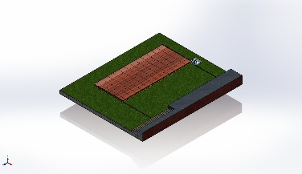 | Solid Body | Mass:7.90405 kg  Volume:0.000988006 m^3  Density:8,000 kg/m^3  Weight:77.4596 N | D:\SWIMMING POOL ENCLOSER'S\SWIMMING POOL DECK\3D MODEL\POST MOTOR BASE PLATE.SLDPRT  Jun 19 11:17:09 2025
Boss-Extrude5  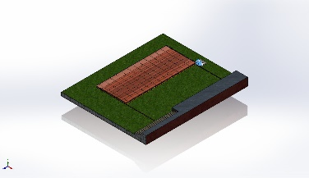 | Solid Body | Mass:87.3617 kg  Volume:0.0109202 m^3  Density:8,000 kg/m^3  Weight:856.144 N | D:\SWIMMING POOL ENCLOSER'S\SWIMMING POOL DECK\3D MODEL\PRACTICE NICE RB 1T.SLDPRT  Jun 9 18:16:52 2025
Cut-Extrude108  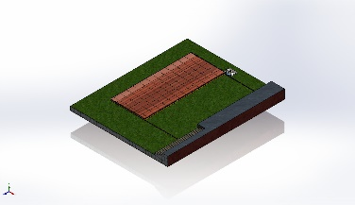 | Solid Body | Mass:0.800519 kg  Volume:0.000100065 m^3  Density:8,000 kg/m^3  Weight:7.84509 N | D:\SWIMMING POOL ENCLOSER'S\SWIMMING POOL DECK\3D MODEL\RACK CUT PART 2.SLDPRT  Jun 10 15:25:43 2025
Cut-Extrude108  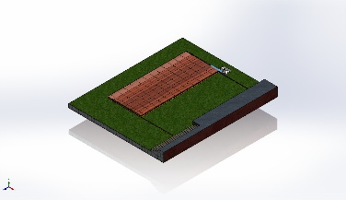 | Solid Body | Mass:6.33379 kg  Volume:0.000791724 m^3  Density:8,000 kg/m^3  Weight:62.0712 N | D:\SWIMMING POOL ENCLOSER'S\SWIMMING POOL DECK\3D MODEL\RACK CUT PART.SLDPRT  Jun 10 15:23:57 2025
CBORE for M10 Hex Head Bolt1  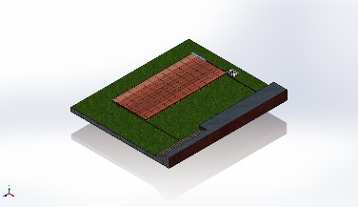 | Solid Body | Mass:7.36886 kg  Volume:0.000921107 m^3  Density:8,000 kg/m^3  Weight:72.2148 N | D:\SWIMMING POOL ENCLOSER'S\SWIMMING POOL DECK\3D MODEL\RACK.SLDPRT  Jun 9 10:39:45 2025
CBORE for M10 Hex Head Bolt1  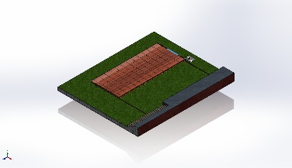 | Solid Body | Mass:7.36886 kg  Volume:0.000921107 m^3  Density:8,000 kg/m^3  Weight:72.2148 N | D:\SWIMMING POOL ENCLOSER'S\SWIMMING POOL DECK\3D MODEL\RACK.SLDPRT  Jun 9 10:39:45 2025
Sweep1  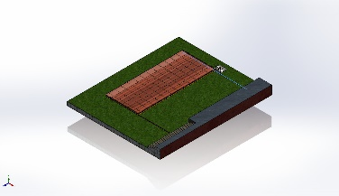 | Solid Body | Mass:2.0629 kg  Volume:0.000257862 m^3  Density:8,000 kg/m^3  Weight:20.2164 N | D:\SWIMMING POOL ENCLOSER'S\SWIMMING POOL DECK\3D MODEL\SLINDING ROD.SLDPRT  Jun 20 17:01:52 2025
Sweep1  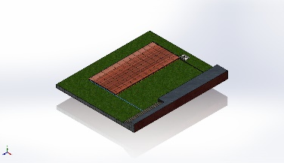 | Solid Body | Mass:2.0629 kg  Volume:0.000257862 m^3  Density:8,000 kg/m^3  Weight:20.2164 N | D:\SWIMMING POOL ENCLOSER'S\SWIMMING POOL DECK\3D MODEL\SLINDING ROD.SLDPRT  Jun 20 17:01:52 2025
Boss-Extrude1  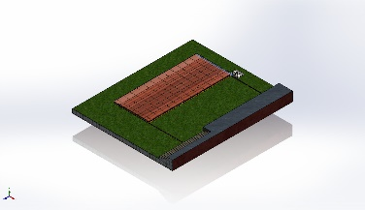 | Solid Body | Mass:3.82608 kg  Volume:0.00047826 m^3  Density:8,000 kg/m^3  Weight:37.4956 N | D:\SWIMMING POOL ENCLOSER'S\SWIMMING POOL DECK\3D MODEL\closing sheet.SLDPRT  Jun 10 18:08:27 2025
Boss-Extrude1  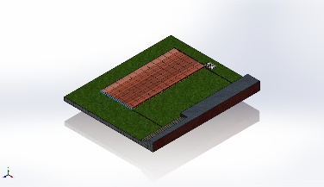 | Solid Body | Mass:3.82608 kg  Volume:0.00047826 m^3  Density:8,000 kg/m^3  Weight:37.4956 N | D:\SWIMMING POOL ENCLOSER'S\SWIMMING POOL DECK\3D MODEL\closing sheet.SLDPRT  Jun 10 18:08:27 2025
Beam Bodies:
Document Name and Reference | Formulation | Properties | Document Path/Date Modified
SolidBody 1(Square tube 40 X 40 X 4(1)[75])  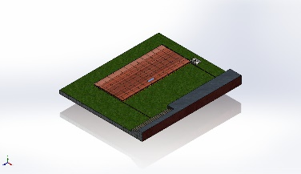 | Beam – Uniform C/S | Section Standard-weldment profiles/iso/square tube  Section Area: 0.000534796m^2  Length:455mm  Volume:0.000243332m^3  Mass Density:8,000kg/m^3  Mass:1.94666kg  Weight:19.0773N | D:\SWIMMING POOL ENCLOSER'S\SWIMMING POOL DECK\3D MODEL\PANEL.SLDPRT  Jun 21 09:14:12 2025
SolidBody 2(Square tube 40 X 40 X 4(1)[5])  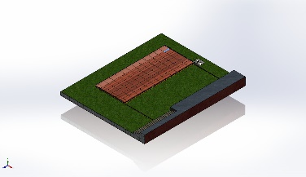 | Beam – Uniform C/S | Section Standard-weldment profiles/iso/square tube  Section Area: 0.000534796m^2  Length:455mm  Volume:0.000243332m^3  Mass Density:8,000kg/m^3  Mass:1.94666kg  Weight:19.0773N | D:\SWIMMING POOL ENCLOSER'S\SWIMMING POOL DECK\3D MODEL\PANEL.SLDPRT  Jun 21 09:14:12 2025
SolidBody 3(Square tube 40 X 40 X 4(1)[30])  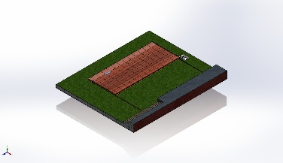 | Beam – Uniform C/S | Section Standard-weldment profiles/iso/square tube  Section Area: 0.000534796m^2  Length:455mm  Volume:0.000243332m^3  Mass Density:8,000kg/m^3  Mass:1.94666kg  Weight:19.0773N | D:\SWIMMING POOL ENCLOSER'S\SWIMMING POOL DECK\3D MODEL\PANEL.SLDPRT  Jun 21 09:14:12 2025
SolidBody 4(Square tube 40 X 40 X 4(1)[37])  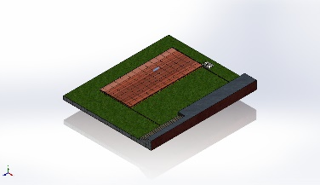 | Beam – Uniform C/S | Section Standard-weldment profiles/iso/square tube  Section Area: 0.000534796m^2  Length:455mm  Volume:0.000243332m^3  Mass Density:8,000kg/m^3  Mass:1.94666kg  Weight:19.0773N | D:\SWIMMING POOL ENCLOSER'S\SWIMMING POOL DECK\3D MODEL\PANEL.SLDPRT  Jun 21 09:14:12 2025
SolidBody 5(Square tube 40 X 40 X 4(1)[14])  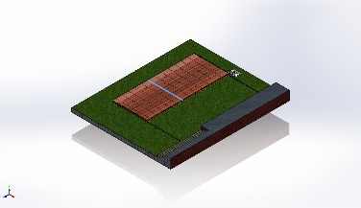 | Beam – Uniform C/S | Section Standard-weldment profiles/iso/square tube  Section Area: 0.000534796m^2  Length:2,577mm  Volume:0.00137817m^3  Mass Density:8,000kg/m^3  Mass:11.0254kg  Weight:108.049N | D:\SWIMMING POOL ENCLOSER'S\SWIMMING POOL DECK\3D MODEL\PANEL.SLDPRT  Jun 21 09:14:12 2025
SolidBody 6(Square tube 40 X 40 X 4(1)[45])  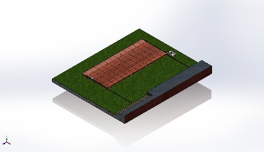 | Beam – Uniform C/S | Section Standard-weldment profiles/iso/square tube  Section Area: 0.000534796m^2  Length:175mm  Volume:9.35894e-05m^3  Mass Density:8,000kg/m^3  Mass:0.748715kg  Weight:7.33741N | D:\SWIMMING POOL ENCLOSER'S\SWIMMING POOL DECK\3D MODEL\PANEL.SLDPRT  Jun 21 09:14:12 2025
SolidBody 7(Square tube 40 X 40 X 4(1)[52])  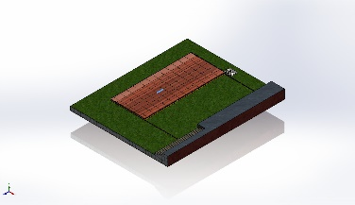 | Beam – Uniform C/S | Section Standard-weldment profiles/iso/square tube  Section Area: 0.000534796m^2  Length:455mm  Volume:0.000243332m^3  Mass Density:8,000kg/m^3  Mass:1.94666kg  Weight:19.0773N | D:\SWIMMING POOL ENCLOSER'S\SWIMMING POOL DECK\3D MODEL\PANEL.SLDPRT  Jun 21 09:14:12 2025
SolidBody 8(Square tube 40 X 40 X 4(1)[60])  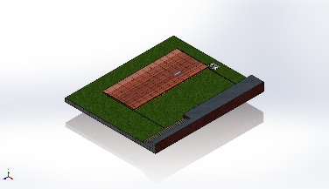 | Beam – Uniform C/S | Section Standard-weldment profiles/iso/square tube  Section Area: 0.000534796m^2  Length:455mm  Volume:0.000243332m^3  Mass Density:8,000kg/m^3  Mass:1.94666kg  Weight:19.0773N | D:\SWIMMING POOL ENCLOSER'S\SWIMMING POOL DECK\3D MODEL\PANEL.SLDPRT  Jun 21 09:14:12 2025
SolidBody 9(Square tube 40 X 40 X 4(1)[67])  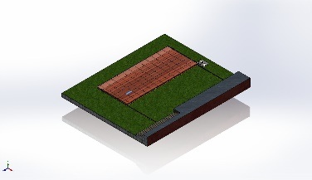 | Beam – Uniform C/S | Section Standard-weldment profiles/iso/square tube  Section Area: 0.000534796m^2  Length:455mm  Volume:0.000243332m^3  Mass Density:8,000kg/m^3  Mass:1.94666kg  Weight:19.0773N | D:\SWIMMING POOL ENCLOSER'S\SWIMMING POOL DECK\3D MODEL\PANEL.SLDPRT  Jun 21 09:14:12 2025
SolidBody 10(Square tube 40 X 40 X 4(1)[74])  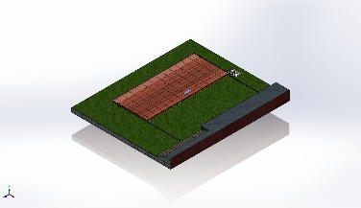 | Beam – Uniform C/S | Section Standard-weldment profiles/iso/square tube  Section Area: 0.000534796m^2  Length:455mm  Volume:0.000243332m^3  Mass Density:8,000kg/m^3  Mass:1.94666kg  Weight:19.0773N | D:\SWIMMING POOL ENCLOSER'S\SWIMMING POOL DECK\3D MODEL\PANEL.SLDPRT  Jun 21 09:14:12 2025
SolidBody 11(Square tube 40 X 40 X 4(1)[22])  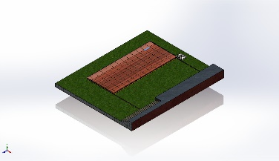 | Beam – Uniform C/S | Section Standard-weldment profiles/iso/square tube  Section Area: 0.000534796m^2  Length:455mm  Volume:0.000243332m^3  Mass Density:8,000kg/m^3  Mass:1.94666kg  Weight:19.0773N | D:\SWIMMING POOL ENCLOSER'S\SWIMMING POOL DECK\3D MODEL\PANEL.SLDPRT  Jun 21 09:14:12 2025
SolidBody 12(Square tube 40 X 40 X 4(1)[29])  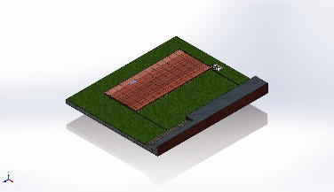 | Beam – Uniform C/S | Section Standard-weldment profiles/iso/square tube  Section Area: 0.000534796m^2  Length:455mm  Volume:0.000243332m^3  Mass Density:8,000kg/m^3  Mass:1.94666kg  Weight:19.0773N | D:\SWIMMING POOL ENCLOSER'S\SWIMMING POOL DECK\3D MODEL\PANEL.SLDPRT  Jun 21 09:14:12 2025
SolidBody 13(Square tube 40 X 40 X 4(1)[35])  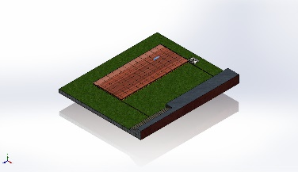 | Beam – Uniform C/S | Section Standard-weldment profiles/iso/square tube  Section Area: 0.000534796m^2  Length:455mm  Volume:0.000243332m^3  Mass Density:8,000kg/m^3  Mass:1.94666kg  Weight:19.0773N | D:\SWIMMING POOL ENCLOSER'S\SWIMMING POOL DECK\3D MODEL\PANEL.SLDPRT  Jun 21 09:14:12 2025
SolidBody 14(Square tube 40 X 40 X 4(1)[17])  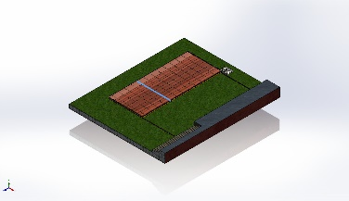 | Beam – Uniform C/S | Section Standard-weldment profiles/iso/square tube  Section Area: 0.000534796m^2  Length:2,577mm  Volume:0.00137817m^3  Mass Density:8,000kg/m^3  Mass:11.0254kg  Weight:108.049N | D:\SWIMMING POOL ENCLOSER'S\SWIMMING POOL DECK\3D MODEL\PANEL.SLDPRT  Jun 21 09:14:12 2025
SolidBody 15(Square tube 40 X 40 X 4(1)[44])  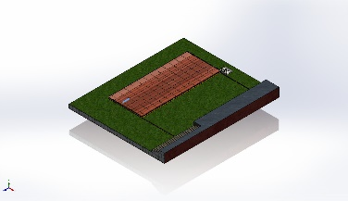 | Beam – Uniform C/S | Section Standard-weldment profiles/iso/square tube  Section Area: 0.000534796m^2  Length:455mm  Volume:0.000243332m^3  Mass Density:8,000kg/m^3  Mass:1.94666kg  Weight:19.0773N | D:\SWIMMING POOL ENCLOSER'S\SWIMMING POOL DECK\3D MODEL\PANEL.SLDPRT  Jun 21 09:14:12 2025
SolidBody 16(Square tube 40 X 40 X 4(1)[51])  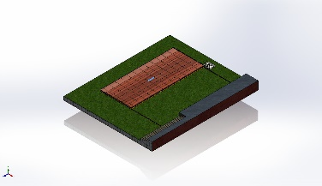 | Beam – Uniform C/S | Section Standard-weldment profiles/iso/square tube  Section Area: 0.000534796m^2  Length:455mm  Volume:0.000243332m^3  Mass Density:8,000kg/m^3  Mass:1.94666kg  Weight:19.0773N | D:\SWIMMING POOL ENCLOSER'S\SWIMMING POOL DECK\3D MODEL\PANEL.SLDPRT  Jun 21 09:14:12 2025
SolidBody 17(Square tube 40 X 40 X 4(1)[15])  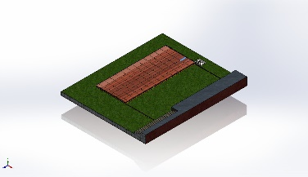 | Beam – Uniform C/S | Section Standard-weldment profiles/iso/square tube  Section Area: 0.000534796m^2  Length:455mm  Volume:0.000243332m^3  Mass Density:8,000kg/m^3  Mass:1.94666kg  Weight:19.0773N | D:\SWIMMING POOL ENCLOSER'S\SWIMMING POOL DECK\3D MODEL\PANEL.SLDPRT  Jun 21 09:14:12 2025
SolidBody 18(Square tube 40 X 40 X 4(1)[66])  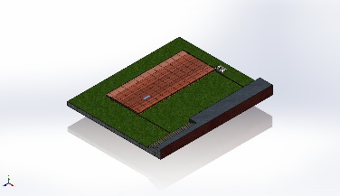 | Beam – Uniform C/S | Section Standard-weldment profiles/iso/square tube  Section Area: 0.000534796m^2  Length:455mm  Volume:0.000243332m^3  Mass Density:8,000kg/m^3  Mass:1.94666kg  Weight:19.0773N | D:\SWIMMING POOL ENCLOSER'S\SWIMMING POOL DECK\3D MODEL\PANEL.SLDPRT  Jun 21 09:14:12 2025
SolidBody 19(Square tube 40 X 40 X 4(1)[73])  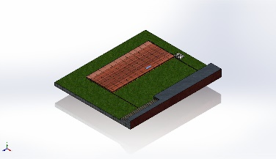 | Beam – Uniform C/S | Section Standard-weldment profiles/iso/square tube  Section Area: 0.000534796m^2  Length:455mm  Volume:0.000243332m^3  Mass Density:8,000kg/m^3  Mass:1.94666kg  Weight:19.0773N | D:\SWIMMING POOL ENCLOSER'S\SWIMMING POOL DECK\3D MODEL\PANEL.SLDPRT  Jun 21 09:14:12 2025
SolidBody 20(Square tube 40 X 40 X 4(1)[81])  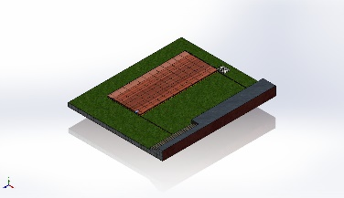 | Beam – Uniform C/S | Section Standard-weldment profiles/iso/square tube  Section Area: 0.000534796m^2  Length:175mm  Volume:9.35894e-05m^3  Mass Density:8,000kg/m^3  Mass:0.748715kg  Weight:7.33741N | D:\SWIMMING POOL ENCLOSER'S\SWIMMING POOL DECK\3D MODEL\PANEL.SLDPRT  Jun 21 09:14:12 2025
SolidBody 21(Square tube 40 X 40 X 4(1)[6])  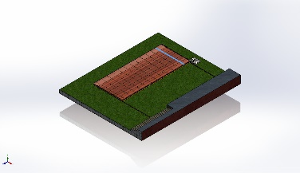 | Beam – Uniform C/S | Section Standard-weldment profiles/iso/square tube  Section Area: 0.000534796m^2  Length:2,577mm  Volume:0.00137817m^3  Mass Density:8,000kg/m^3  Mass:11.0254kg  Weight:108.049N | D:\SWIMMING POOL ENCLOSER'S\SWIMMING POOL DECK\3D MODEL\PANEL.SLDPRT  Jun 21 09:14:12 2025
SolidBody 22(Square tube 40 X 40 X 4(1)[28])  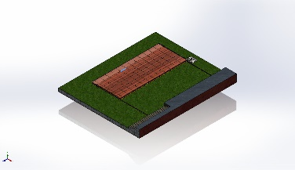 | Beam – Uniform C/S | Section Standard-weldment profiles/iso/square tube  Section Area: 0.000534796m^2  Length:455mm  Volume:0.000243332m^3  Mass Density:8,000kg/m^3  Mass:1.94666kg  Weight:19.0773N | D:\SWIMMING POOL ENCLOSER'S\SWIMMING POOL DECK\3D MODEL\PANEL.SLDPRT  Jun 21 09:14:12 2025
SolidBody 23(Square tube 40 X 40 X 4(1)[36])  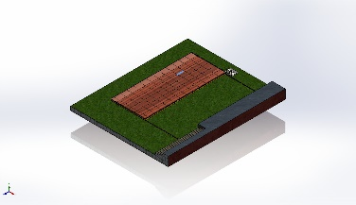 | Beam – Uniform C/S | Section Standard-weldment profiles/iso/square tube  Section Area: 0.000534796m^2  Length:455mm  Volume:0.000243332m^3  Mass Density:8,000kg/m^3  Mass:1.94666kg  Weight:19.0773N | D:\SWIMMING POOL ENCLOSER'S\SWIMMING POOL DECK\3D MODEL\PANEL.SLDPRT  Jun 21 09:14:12 2025
SolidBody 24(Square tube 40 X 40 X 4(1)[18])  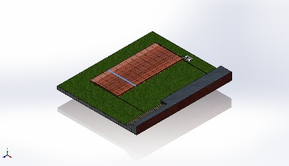 | Beam – Uniform C/S | Section Standard-weldment profiles/iso/square tube  Section Area: 0.000534796m^2  Length:2,577mm  Volume:0.00137817m^3  Mass Density:8,000kg/m^3  Mass:11.0254kg  Weight:108.049N | D:\SWIMMING POOL ENCLOSER'S\SWIMMING POOL DECK\3D MODEL\PANEL.SLDPRT  Jun 21 09:14:12 2025
SolidBody 25(Square tube 40 X 40 X 4(1)[43])  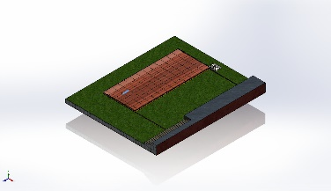 | Beam – Uniform C/S | Section Standard-weldment profiles/iso/square tube  Section Area: 0.000534796m^2  Length:455mm  Volume:0.000243332m^3  Mass Density:8,000kg/m^3  Mass:1.94666kg  Weight:19.0773N | D:\SWIMMING POOL ENCLOSER'S\SWIMMING POOL DECK\3D MODEL\PANEL.SLDPRT  Jun 21 09:14:12 2025
SolidBody 26(Square tube 40 X 40 X 4(1)[21])  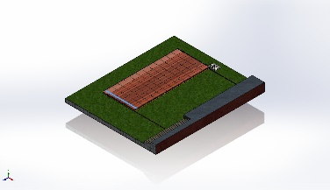 | Beam – Uniform C/S | Section Standard-weldment profiles/iso/square tube  Section Area: 0.000534796m^2  Length:2,577mm  Volume:0.00137817m^3  Mass Density:8,000kg/m^3  Mass:11.0254kg  Weight:108.049N | D:\SWIMMING POOL ENCLOSER'S\SWIMMING POOL DECK\3D MODEL\PANEL.SLDPRT  Jun 21 09:14:12 2025
SolidBody 27(Square tube 40 X 40 X 4(1)[50])  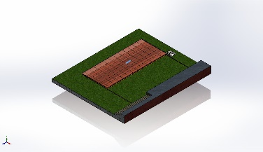 | Beam – Uniform C/S | Section Standard-weldment profiles/iso/square tube  Section Area: 0.000534796m^2  Length:455mm  Volume:0.000243332m^3  Mass Density:8,000kg/m^3  Mass:1.94666kg  Weight:19.0773N | D:\SWIMMING POOL ENCLOSER'S\SWIMMING POOL DECK\3D MODEL\PANEL.SLDPRT  Jun 21 09:14:12 2025
SolidBody 28(Square tube 40 X 40 X 4(1)[1])  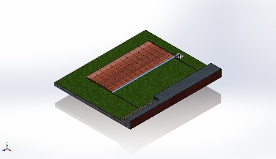 | Beam – Uniform C/S | Section Standard-weldment profiles/iso/square tube  Section Area: 0.000534796m^2  Length:6,155mm  Volume:0.00329173m^3  Mass Density:8,000kg/m^3  Mass:26.3339kg  Weight:258.072N | D:\SWIMMING POOL ENCLOSER'S\SWIMMING POOL DECK\3D MODEL\PANEL.SLDPRT  Jun 21 09:14:12 2025
SolidBody 29(Square tube 40 X 40 X 4(1)[58])  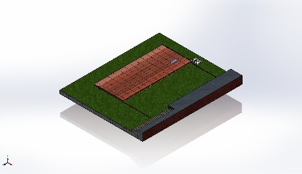 | Beam – Uniform C/S | Section Standard-weldment profiles/iso/square tube  Section Area: 0.000534796m^2  Length:455mm  Volume:0.000243332m^3  Mass Density:8,000kg/m^3  Mass:1.94666kg  Weight:19.0773N | D:\SWIMMING POOL ENCLOSER'S\SWIMMING POOL DECK\3D MODEL\PANEL.SLDPRT  Jun 21 09:14:12 2025
SolidBody 30(Square tube 40 X 40 X 4(1)[65])  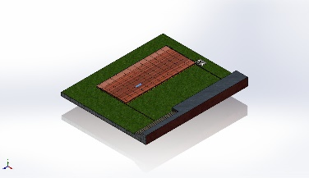 | Beam – Uniform C/S | Section Standard-weldment profiles/iso/square tube  Section Area: 0.000534796m^2  Length:455mm  Volume:0.000243332m^3  Mass Density:8,000kg/m^3  Mass:1.94666kg  Weight:19.0773N | D:\SWIMMING POOL ENCLOSER'S\SWIMMING POOL DECK\3D MODEL\PANEL.SLDPRT  Jun 21 09:14:12 2025
SolidBody 31(Square tube 40 X 40 X 4(1)[71])  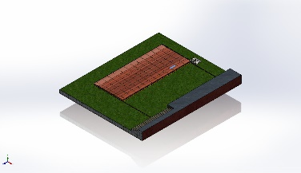 | Beam – Uniform C/S | Section Standard-weldment profiles/iso/square tube  Section Area: 0.000534796m^2  Length:455mm  Volume:0.000243332m^3  Mass Density:8,000kg/m^3  Mass:1.94666kg  Weight:19.0773N | D:\SWIMMING POOL ENCLOSER'S\SWIMMING POOL DECK\3D MODEL\PANEL.SLDPRT  Jun 21 09:14:12 2025
SolidBody 32(Square tube 40 X 40 X 4(1)[80])  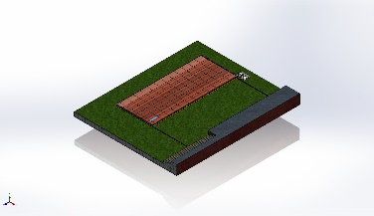 | Beam – Uniform C/S | Section Standard-weldment profiles/iso/square tube  Section Area: 0.000534796m^2  Length:455mm  Volume:0.000243332m^3  Mass Density:8,000kg/m^3  Mass:1.94666kg  Weight:19.0773N | D:\SWIMMING POOL ENCLOSER'S\SWIMMING POOL DECK\3D MODEL\PANEL.SLDPRT  Jun 21 09:14:12 2025
SolidBody 33(Square tube 40 X 40 X 4(1)[27])  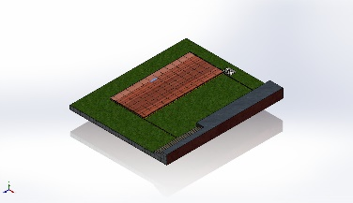 | Beam – Uniform C/S | Section Standard-weldment profiles/iso/square tube  Section Area: 0.000534796m^2  Length:455mm  Volume:0.000243332m^3  Mass Density:8,000kg/m^3  Mass:1.94666kg  Weight:19.0773N | D:\SWIMMING POOL ENCLOSER'S\SWIMMING POOL DECK\3D MODEL\PANEL.SLDPRT  Jun 21 09:14:12 2025
SolidBody 34(Square tube 40 X 40 X 4(1)[10])  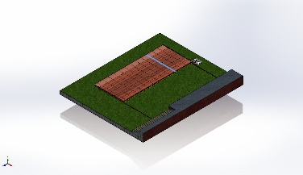 | Beam – Uniform C/S | Section Standard-weldment profiles/iso/square tube  Section Area: 0.000534796m^2  Length:2,577mm  Volume:0.00137817m^3  Mass Density:8,000kg/m^3  Mass:11.0254kg  Weight:108.049N | D:\SWIMMING POOL ENCLOSER'S\SWIMMING POOL DECK\3D MODEL\PANEL.SLDPRT  Jun 21 09:14:12 2025
SolidBody 35(Square tube 40 X 40 X 4(1)[7])  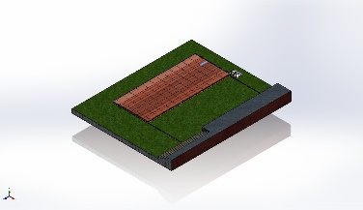 | Beam – Uniform C/S | Section Standard-weldment profiles/iso/square tube  Section Area: 0.000534796m^2  Length:455mm  Volume:0.000243332m^3  Mass Density:8,000kg/m^3  Mass:1.94666kg  Weight:19.0773N | D:\SWIMMING POOL ENCLOSER'S\SWIMMING POOL DECK\3D MODEL\PANEL.SLDPRT  Jun 21 09:14:12 2025
SolidBody 36(Square tube 40 X 40 X 4(1)[42])  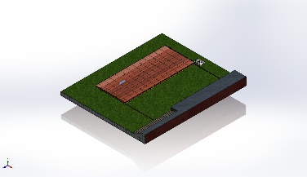 | Beam – Uniform C/S | Section Standard-weldment profiles/iso/square tube  Section Area: 0.000534796m^2  Length:455mm  Volume:0.000243332m^3  Mass Density:8,000kg/m^3  Mass:1.94666kg  Weight:19.0773N | D:\SWIMMING POOL ENCLOSER'S\SWIMMING POOL DECK\3D MODEL\PANEL.SLDPRT  Jun 21 09:14:12 2025
SolidBody 37(Square tube 40 X 40 X 4(1)[19])  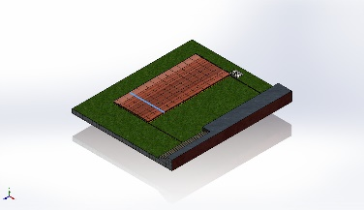 | Beam – Uniform C/S | Section Standard-weldment profiles/iso/square tube  Section Area: 0.000534796m^2  Length:2,577mm  Volume:0.00137817m^3  Mass Density:8,000kg/m^3  Mass:11.0254kg  Weight:108.049N | D:\SWIMMING POOL ENCLOSER'S\SWIMMING POOL DECK\3D MODEL\PANEL.SLDPRT  Jun 21 09:14:12 2025
SolidBody 38(Square tube 40 X 40 X 4(1)[49])  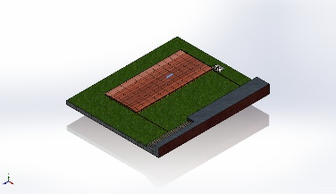 | Beam – Uniform C/S | Section Standard-weldment profiles/iso/square tube  Section Area: 0.000534796m^2  Length:455mm  Volume:0.000243332m^3  Mass Density:8,000kg/m^3  Mass:1.94666kg  Weight:19.0773N | D:\SWIMMING POOL ENCLOSER'S\SWIMMING POOL DECK\3D MODEL\PANEL.SLDPRT  Jun 21 09:14:12 2025
SolidBody 39(Cut-Extrude1[1])  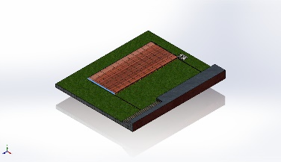 | Beam – Uniform C/S | Section Standard-weldment profiles/iso/square tube  Section Area: 0.000534796m^2  Length:2,617mm  Volume:0.0013568m^3  Mass Density:8,000kg/m^3  Mass:10.8544kg  Weight:106.373N | D:\SWIMMING POOL ENCLOSER'S\SWIMMING POOL DECK\3D MODEL\PANEL.SLDPRT  Jun 21 09:14:12 2025
SolidBody 40(Square tube 40 X 40 X 4(1)[57])  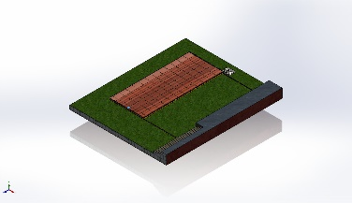 | Beam – Uniform C/S | Section Standard-weldment profiles/iso/square tube  Section Area: 0.000534796m^2  Length:175mm  Volume:9.35894e-05m^3  Mass Density:8,000kg/m^3  Mass:0.748715kg  Weight:7.33741N | D:\SWIMMING POOL ENCLOSER'S\SWIMMING POOL DECK\3D MODEL\PANEL.SLDPRT  Jun 21 09:14:12 2025
SolidBody 41(Square tube 40 X 40 X 4(1)[64])  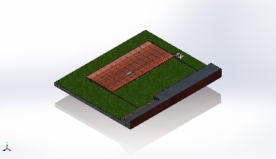 | Beam – Uniform C/S | Section Standard-weldment profiles/iso/square tube  Section Area: 0.000534796m^2  Length:455mm  Volume:0.000243332m^3  Mass Density:8,000kg/m^3  Mass:1.94666kg  Weight:19.0773N | D:\SWIMMING POOL ENCLOSER'S\SWIMMING POOL DECK\3D MODEL\PANEL.SLDPRT  Jun 21 09:14:12 2025
SolidBody 42(Square tube 40 X 40 X 4(1)[72])  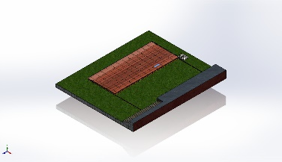 | Beam – Uniform C/S | Section Standard-weldment profiles/iso/square tube  Section Area: 0.000534796m^2  Length:455mm  Volume:0.000243332m^3  Mass Density:8,000kg/m^3  Mass:1.94666kg  Weight:19.0773N | D:\SWIMMING POOL ENCLOSER'S\SWIMMING POOL DECK\3D MODEL\PANEL.SLDPRT  Jun 21 09:14:12 2025
SolidBody 43(Square tube 40 X 40 X 4(1)[79])  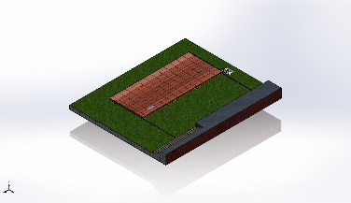 | Beam – Uniform C/S | Section Standard-weldment profiles/iso/square tube  Section Area: 0.000534796m^2  Length:455mm  Volume:0.000243332m^3  Mass Density:8,000kg/m^3  Mass:1.94666kg  Weight:19.0773N | D:\SWIMMING POOL ENCLOSER'S\SWIMMING POOL DECK\3D MODEL\PANEL.SLDPRT  Jun 21 09:14:12 2025
SolidBody 44(Cut-Extrude1[2])  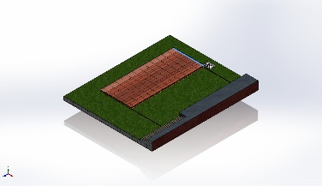 | Beam – Uniform C/S | Section Standard-weldment profiles/iso/square tube  Section Area: 0.000534796m^2  Length:2,617mm  Volume:0.0013568m^3  Mass Density:8,000kg/m^3  Mass:10.8544kg  Weight:106.373N | D:\SWIMMING POOL ENCLOSER'S\SWIMMING POOL DECK\3D MODEL\PANEL.SLDPRT  Jun 21 09:14:12 2025
SolidBody 45(Square tube 40 X 40 X 4(1)[26])  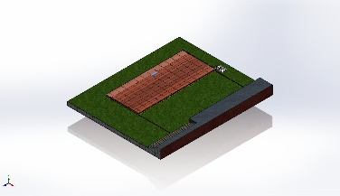 | Beam – Uniform C/S | Section Standard-weldment profiles/iso/square tube  Section Area: 0.000534796m^2  Length:455mm  Volume:0.000243332m^3  Mass Density:8,000kg/m^3  Mass:1.94666kg  Weight:19.0773N | D:\SWIMMING POOL ENCLOSER'S\SWIMMING POOL DECK\3D MODEL\PANEL.SLDPRT  Jun 21 09:14:12 2025
SolidBody 46(Square tube 40 X 40 X 4(1)[9])  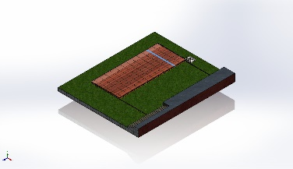 | Beam – Uniform C/S | Section Standard-weldment profiles/iso/square tube  Section Area: 0.000534796m^2  Length:2,577mm  Volume:0.00137817m^3  Mass Density:8,000kg/m^3  Mass:11.0254kg  Weight:108.049N | D:\SWIMMING POOL ENCLOSER'S\SWIMMING POOL DECK\3D MODEL\PANEL.SLDPRT  Jun 21 09:14:12 2025
SolidBody 47(Square tube 40 X 40 X 4(1)[34])  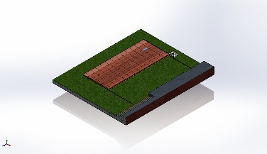 | Beam – Uniform C/S | Section Standard-weldment profiles/iso/square tube  Section Area: 0.000534796m^2  Length:455mm  Volume:0.000243332m^3  Mass Density:8,000kg/m^3  Mass:1.94666kg  Weight:19.0773N | D:\SWIMMING POOL ENCLOSER'S\SWIMMING POOL DECK\3D MODEL\PANEL.SLDPRT  Jun 21 09:14:12 2025
SolidBody 48(Square tube 40 X 40 X 4(1)[41])  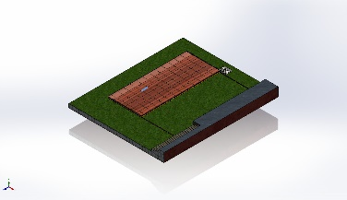 | Beam – Uniform C/S | Section Standard-weldment profiles/iso/square tube  Section Area: 0.000534796m^2  Length:455mm  Volume:0.000243332m^3  Mass Density:8,000kg/m^3  Mass:1.94666kg  Weight:19.0773N | D:\SWIMMING POOL ENCLOSER'S\SWIMMING POOL DECK\3D MODEL\PANEL.SLDPRT  Jun 21 09:14:12 2025
SolidBody 49(Square tube 40 X 40 X 4(1)[20])  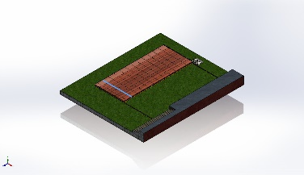 | Beam – Uniform C/S | Section Standard-weldment profiles/iso/square tube  Section Area: 0.000534796m^2  Length:2,577mm  Volume:0.00137817m^3  Mass Density:8,000kg/m^3  Mass:11.0254kg  Weight:108.049N | D:\SWIMMING POOL ENCLOSER'S\SWIMMING POOL DECK\3D MODEL\PANEL.SLDPRT  Jun 21 09:14:12 2025
SolidBody 50(Square tube 40 X 40 X 4(1)[47])  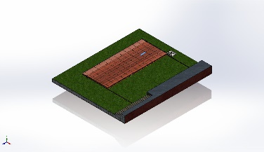 | Beam – Uniform C/S | Section Standard-weldment profiles/iso/square tube  Section Area: 0.000534796m^2  Length:455mm  Volume:0.000243332m^3  Mass Density:8,000kg/m^3  Mass:1.94666kg  Weight:19.0773N | D:\SWIMMING POOL ENCLOSER'S\SWIMMING POOL DECK\3D MODEL\PANEL.SLDPRT  Jun 21 09:14:12 2025
SolidBody 51(Square tube 40 X 40 X 4(1)[3])  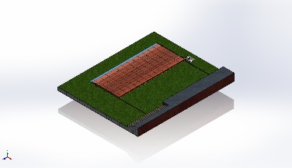 | Beam – Uniform C/S | Section Standard-weldment profiles/iso/square tube  Section Area: 0.000534796m^2  Length:6,155mm  Volume:0.00329173m^3  Mass Density:8,000kg/m^3  Mass:26.3339kg  Weight:258.072N | D:\SWIMMING POOL ENCLOSER'S\SWIMMING POOL DECK\3D MODEL\PANEL.SLDPRT  Jun 21 09:14:12 2025
SolidBody 52(Square tube 40 X 40 X 4(1)[56])  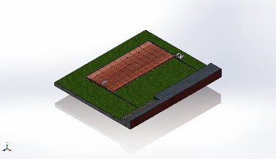 | Beam – Uniform C/S | Section Standard-weldment profiles/iso/square tube  Section Area: 0.000534796m^2  Length:455mm  Volume:0.000243332m^3  Mass Density:8,000kg/m^3  Mass:1.94666kg  Weight:19.0773N | D:\SWIMMING POOL ENCLOSER'S\SWIMMING POOL DECK\3D MODEL\PANEL.SLDPRT  Jun 21 09:14:12 2025
SolidBody 53(Square tube 40 X 40 X 4(1)[63])  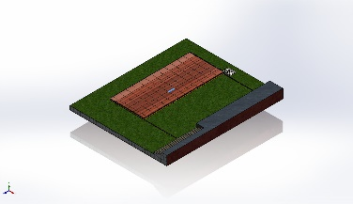 | Beam – Uniform C/S | Section Standard-weldment profiles/iso/square tube  Section Area: 0.000534796m^2  Length:455mm  Volume:0.000243332m^3  Mass Density:8,000kg/m^3  Mass:1.94666kg  Weight:19.0773N | D:\SWIMMING POOL ENCLOSER'S\SWIMMING POOL DECK\3D MODEL\PANEL.SLDPRT  Jun 21 09:14:12 2025
SolidBody 54(Square tube 40 X 40 X 4(1)[16])  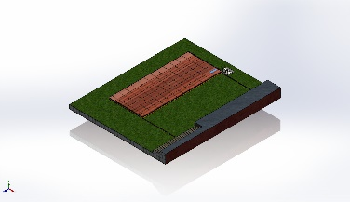 | Beam – Uniform C/S | Section Standard-weldment profiles/iso/square tube  Section Area: 0.000534796m^2  Length:455mm  Volume:0.000243332m^3  Mass Density:8,000kg/m^3  Mass:1.94666kg  Weight:19.0773N | D:\SWIMMING POOL ENCLOSER'S\SWIMMING POOL DECK\3D MODEL\PANEL.SLDPRT  Jun 21 09:14:12 2025
SolidBody 55(Square tube 40 X 40 X 4(1)[78])  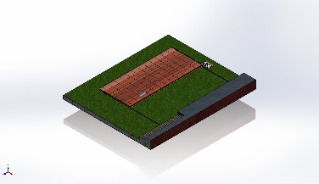 | Beam – Uniform C/S | Section Standard-weldment profiles/iso/square tube  Section Area: 0.000534796m^2  Length:455mm  Volume:0.000243332m^3  Mass Density:8,000kg/m^3  Mass:1.94666kg  Weight:19.0773N | D:\SWIMMING POOL ENCLOSER'S\SWIMMING POOL DECK\3D MODEL\PANEL.SLDPRT  Jun 21 09:14:12 2025
SolidBody 56(Square tube 40 X 40 X 4(1)[25])  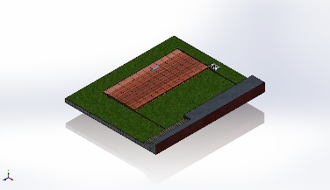 | Beam – Uniform C/S | Section Standard-weldment profiles/iso/square tube  Section Area: 0.000534796m^2  Length:455mm  Volume:0.000243332m^3  Mass Density:8,000kg/m^3  Mass:1.94666kg  Weight:19.0773N | D:\SWIMMING POOL ENCLOSER'S\SWIMMING POOL DECK\3D MODEL\PANEL.SLDPRT  Jun 21 09:14:12 2025
SolidBody 57(Square tube 40 X 40 X 4(1)[11])  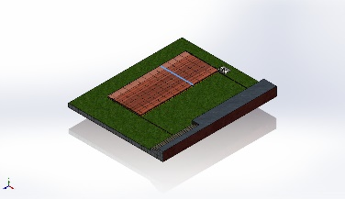 | Beam – Uniform C/S | Section Standard-weldment profiles/iso/square tube  Section Area: 0.000534796m^2  Length:2,577mm  Volume:0.00137817m^3  Mass Density:8,000kg/m^3  Mass:11.0254kg  Weight:108.049N | D:\SWIMMING POOL ENCLOSER'S\SWIMMING POOL DECK\3D MODEL\PANEL.SLDPRT  Jun 21 09:14:12 2025
SolidBody 58(Square tube 40 X 40 X 4(1)[33])  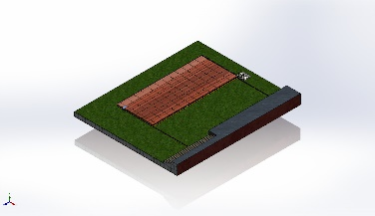 | Beam – Uniform C/S | Section Standard-weldment profiles/iso/square tube  Section Area: 0.000534796m^2  Length:175mm  Volume:9.35894e-05m^3  Mass Density:8,000kg/m^3  Mass:0.748715kg  Weight:7.33741N | D:\SWIMMING POOL ENCLOSER'S\SWIMMING POOL DECK\3D MODEL\PANEL.SLDPRT  Jun 21 09:14:12 2025
SolidBody 59(Square tube 40 X 40 X 4(1)[40])  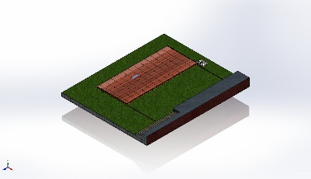 | Beam – Uniform C/S | Section Standard-weldment profiles/iso/square tube  Section Area: 0.000534796m^2  Length:455mm  Volume:0.000243332m^3  Mass Density:8,000kg/m^3  Mass:1.94666kg  Weight:19.0773N | D:\SWIMMING POOL ENCLOSER'S\SWIMMING POOL DECK\3D MODEL\PANEL.SLDPRT  Jun 21 09:14:12 2025
SolidBody 60(Square tube 40 X 40 X 4(1)[48])  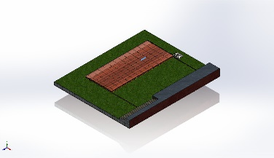 | Beam – Uniform C/S | Section Standard-weldment profiles/iso/square tube  Section Area: 0.000534796m^2  Length:455mm  Volume:0.000243332m^3  Mass Density:8,000kg/m^3  Mass:1.94666kg  Weight:19.0773N | D:\SWIMMING POOL ENCLOSER'S\SWIMMING POOL DECK\3D MODEL\PANEL.SLDPRT  Jun 21 09:14:12 2025
SolidBody 61(Square tube 40 X 40 X 4(1)[55])  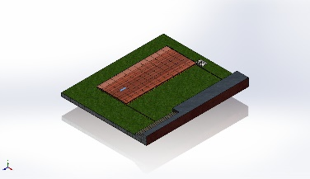 | Beam – Uniform C/S | Section Standard-weldment profiles/iso/square tube  Section Area: 0.000534796m^2  Length:455mm  Volume:0.000243332m^3  Mass Density:8,000kg/m^3  Mass:1.94666kg  Weight:19.0773N | D:\SWIMMING POOL ENCLOSER'S\SWIMMING POOL DECK\3D MODEL\PANEL.SLDPRT  Jun 21 09:14:12 2025
SolidBody 62(Square tube 40 X 40 X 4(1)[62])  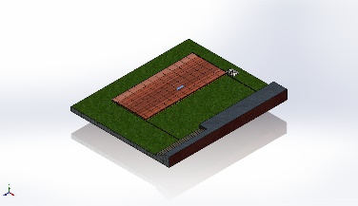 | Beam – Uniform C/S | Section Standard-weldment profiles/iso/square tube  Section Area: 0.000534796m^2  Length:455mm  Volume:0.000243332m^3  Mass Density:8,000kg/m^3  Mass:1.94666kg  Weight:19.0773N | D:\SWIMMING POOL ENCLOSER'S\SWIMMING POOL DECK\3D MODEL\PANEL.SLDPRT  Jun 21 09:14:12 2025
SolidBody 63(Square tube 40 X 40 X 4(1)[70])  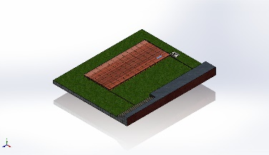 | Beam – Uniform C/S | Section Standard-weldment profiles/iso/square tube  Section Area: 0.000534796m^2  Length:455mm  Volume:0.000243332m^3  Mass Density:8,000kg/m^3  Mass:1.94666kg  Weight:19.0773N | D:\SWIMMING POOL ENCLOSER'S\SWIMMING POOL DECK\3D MODEL\PANEL.SLDPRT  Jun 21 09:14:12 2025
SolidBody 64(Square tube 40 X 40 X 4(1)[77])  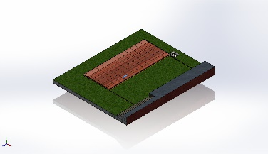 | Beam – Uniform C/S | Section Standard-weldment profiles/iso/square tube  Section Area: 0.000534796m^2  Length:455mm  Volume:0.000243332m^3  Mass Density:8,000kg/m^3  Mass:1.94666kg  Weight:19.0773N | D:\SWIMMING POOL ENCLOSER'S\SWIMMING POOL DECK\3D MODEL\PANEL.SLDPRT  Jun 21 09:14:12 2025
SolidBody 65(Square tube 40 X 40 X 4(1)[23])  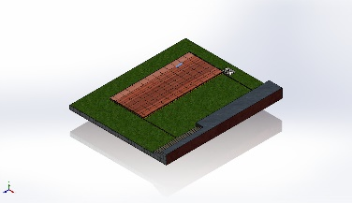 | Beam – Uniform C/S | Section Standard-weldment profiles/iso/square tube  Section Area: 0.000534796m^2  Length:455mm  Volume:0.000243332m^3  Mass Density:8,000kg/m^3  Mass:1.94666kg  Weight:19.0773N | D:\SWIMMING POOL ENCLOSER'S\SWIMMING POOL DECK\3D MODEL\PANEL.SLDPRT  Jun 21 09:14:12 2025
SolidBody 66(Square tube 40 X 40 X 4(1)[32])  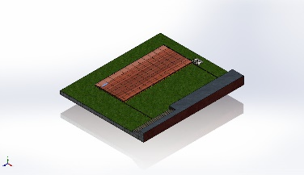 | Beam – Uniform C/S | Section Standard-weldment profiles/iso/square tube  Section Area: 0.000534796m^2  Length:455mm  Volume:0.000243332m^3  Mass Density:8,000kg/m^3  Mass:1.94666kg  Weight:19.0773N | D:\SWIMMING POOL ENCLOSER'S\SWIMMING POOL DECK\3D MODEL\PANEL.SLDPRT  Jun 21 09:14:12 2025
SolidBody 67(Square tube 40 X 40 X 4(1)[12])  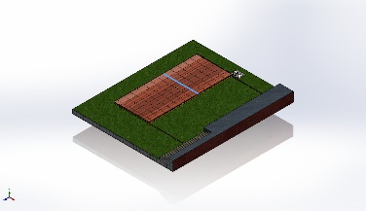 | Beam – Uniform C/S | Section Standard-weldment profiles/iso/square tube  Section Area: 0.000534796m^2  Length:2,577mm  Volume:0.00137817m^3  Mass Density:8,000kg/m^3  Mass:11.0254kg  Weight:108.049N | D:\SWIMMING POOL ENCLOSER'S\SWIMMING POOL DECK\3D MODEL\PANEL.SLDPRT  Jun 21 09:14:12 2025
SolidBody 68(Square tube 40 X 40 X 4(1)[39])  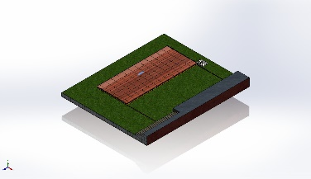 | Beam – Uniform C/S | Section Standard-weldment profiles/iso/square tube  Section Area: 0.000534796m^2  Length:455mm  Volume:0.000243332m^3  Mass Density:8,000kg/m^3  Mass:1.94666kg  Weight:19.0773N | D:\SWIMMING POOL ENCLOSER'S\SWIMMING POOL DECK\3D MODEL\PANEL.SLDPRT  Jun 21 09:14:12 2025
SolidBody 69(Square tube 40 X 40 X 4(1)[8])  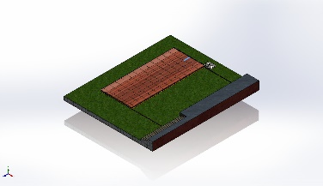 | Beam – Uniform C/S | Section Standard-weldment profiles/iso/square tube  Section Area: 0.000534796m^2  Length:455mm  Volume:0.000243332m^3  Mass Density:8,000kg/m^3  Mass:1.94666kg  Weight:19.0773N | D:\SWIMMING POOL ENCLOSER'S\SWIMMING POOL DECK\3D MODEL\PANEL.SLDPRT  Jun 21 09:14:12 2025
SolidBody 70(Square tube 40 X 40 X 4(1)[54])  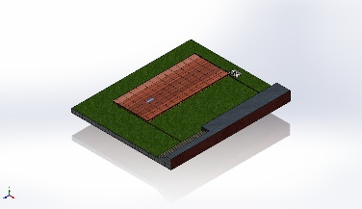 | Beam – Uniform C/S | Section Standard-weldment profiles/iso/square tube  Section Area: 0.000534796m^2  Length:455mm  Volume:0.000243332m^3  Mass Density:8,000kg/m^3  Mass:1.94666kg  Weight:19.0773N | D:\SWIMMING POOL ENCLOSER'S\SWIMMING POOL DECK\3D MODEL\PANEL.SLDPRT  Jun 21 09:14:12 2025
SolidBody 71(Square tube 40 X 40 X 4(1)[61])  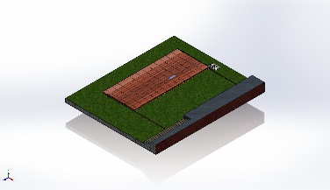 | Beam – Uniform C/S | Section Standard-weldment profiles/iso/square tube  Section Area: 0.000534796m^2  Length:455mm  Volume:0.000243332m^3  Mass Density:8,000kg/m^3  Mass:1.94666kg  Weight:19.0773N | D:\SWIMMING POOL ENCLOSER'S\SWIMMING POOL DECK\3D MODEL\PANEL.SLDPRT  Jun 21 09:14:12 2025
SolidBody 72(Square tube 40 X 40 X 4(1)[69])  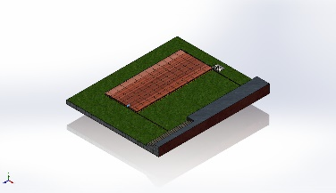 | Beam – Uniform C/S | Section Standard-weldment profiles/iso/square tube  Section Area: 0.000534796m^2  Length:175mm  Volume:9.35894e-05m^3  Mass Density:8,000kg/m^3  Mass:0.748715kg  Weight:7.33741N | D:\SWIMMING POOL ENCLOSER'S\SWIMMING POOL DECK\3D MODEL\PANEL.SLDPRT  Jun 21 09:14:12 2025
SolidBody 73(Square tube 40 X 40 X 4(1)[76])  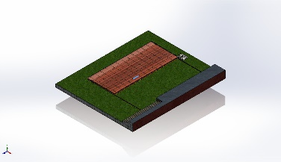 | Beam – Uniform C/S | Section Standard-weldment profiles/iso/square tube  Section Area: 0.000534796m^2  Length:455mm  Volume:0.000243332m^3  Mass Density:8,000kg/m^3  Mass:1.94666kg  Weight:19.0773N | D:\SWIMMING POOL ENCLOSER'S\SWIMMING POOL DECK\3D MODEL\PANEL.SLDPRT  Jun 21 09:14:12 2025
SolidBody 74(Square tube 40 X 40 X 4(1)[24])  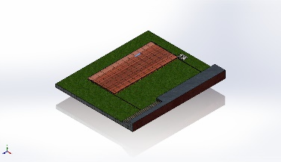 | Beam – Uniform C/S | Section Standard-weldment profiles/iso/square tube  Section Area: 0.000534796m^2  Length:455mm  Volume:0.000243332m^3  Mass Density:8,000kg/m^3  Mass:1.94666kg  Weight:19.0773N | D:\SWIMMING POOL ENCLOSER'S\SWIMMING POOL DECK\3D MODEL\PANEL.SLDPRT  Jun 21 09:14:12 2025
SolidBody 75(Square tube 40 X 40 X 4(1)[31])  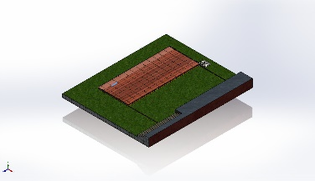 | Beam – Uniform C/S | Section Standard-weldment profiles/iso/square tube  Section Area: 0.000534796m^2  Length:455mm  Volume:0.000243332m^3  Mass Density:8,000kg/m^3  Mass:1.94666kg  Weight:19.0773N | D:\SWIMMING POOL ENCLOSER'S\SWIMMING POOL DECK\3D MODEL\PANEL.SLDPRT  Jun 21 09:14:12 2025
SolidBody 76(Square tube 40 X 40 X 4(1)[13])  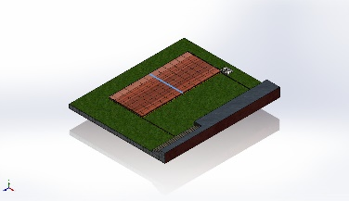 | Beam – Uniform C/S | Section Standard-weldment profiles/iso/square tube  Section Area: 0.000534796m^2  Length:2,577mm  Volume:0.00137817m^3  Mass Density:8,000kg/m^3  Mass:11.0254kg  Weight:108.049N | D:\SWIMMING POOL ENCLOSER'S\SWIMMING POOL DECK\3D MODEL\PANEL.SLDPRT  Jun 21 09:14:12 2025
SolidBody 77(Square tube 40 X 40 X 4(1)[38])  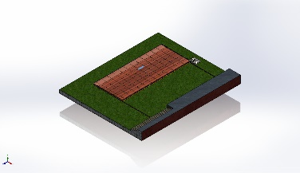 | Beam – Uniform C/S | Section Standard-weldment profiles/iso/square tube  Section Area: 0.000534796m^2  Length:455mm  Volume:0.000243332m^3  Mass Density:8,000kg/m^3  Mass:1.94666kg  Weight:19.0773N | D:\SWIMMING POOL ENCLOSER'S\SWIMMING POOL DECK\3D MODEL\PANEL.SLDPRT  Jun 21 09:14:12 2025
SolidBody 78(Square tube 40 X 40 X 4(1)[46])  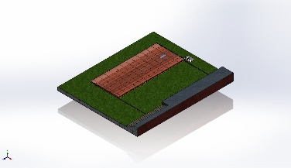 | Beam – Uniform C/S | Section Standard-weldment profiles/iso/square tube  Section Area: 0.000534796m^2  Length:455mm  Volume:0.000243332m^3  Mass Density:8,000kg/m^3  Mass:1.94666kg  Weight:19.0773N | D:\SWIMMING POOL ENCLOSER'S\SWIMMING POOL DECK\3D MODEL\PANEL.SLDPRT  Jun 21 09:14:12 2025
SolidBody 79(Square tube 40 X 40 X 4(1)[53])  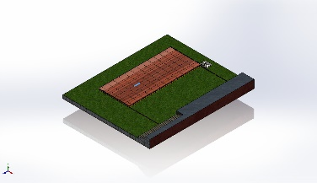 | Beam – Uniform C/S | Section Standard-weldment profiles/iso/square tube  Section Area: 0.000534796m^2  Length:455mm  Volume:0.000243332m^3  Mass Density:8,000kg/m^3  Mass:1.94666kg  Weight:19.0773N | D:\SWIMMING POOL ENCLOSER'S\SWIMMING POOL DECK\3D MODEL\PANEL.SLDPRT  Jun 21 09:14:12 2025
SolidBody 80(Square tube 40 X 40 X 4(1)[59])  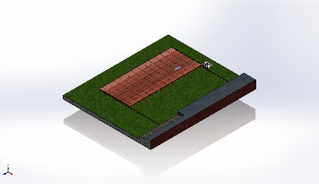 | Beam – Uniform C/S | Section Standard-weldment profiles/iso/square tube  Section Area: 0.000534796m^2  Length:455mm  Volume:0.000243332m^3  Mass Density:8,000kg/m^3  Mass:1.94666kg  Weight:19.0773N | D:\SWIMMING POOL ENCLOSER'S\SWIMMING POOL DECK\3D MODEL\PANEL.SLDPRT  Jun 21 09:14:12 2025
SolidBody 81(Square tube 40 X 40 X 4(1)[68])  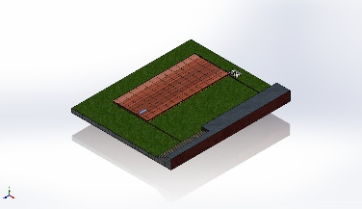 | Beam – Uniform C/S | Section Standard-weldment profiles/iso/square tube  Section Area: 0.000534796m^2  Length:455mm  Volume:0.000243332m^3  Mass Density:8,000kg/m^3  Mass:1.94666kg  Weight:19.0773N | D:\SWIMMING POOL ENCLOSER'S\SWIMMING POOL DECK\3D MODEL\PANEL.SLDPRT  Jun 21 09:14:12 2025
SolidBody 1(Square tube 20 X 20 X 2(1))  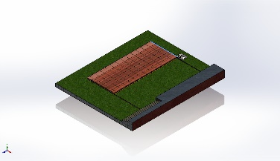 | Beam – Uniform C/S | Section Standard-weldment profiles/iso/square tube  Section Area: 0.000133699m^2  Length:2,657mm  Volume:0.000355239m^3  Mass Density:8,000kg/m^3  Mass:2.84191kg  Weight:27.8507N | D:\SWIMMING POOL ENCLOSER'S\SWIMMING POOL DECK\3D MODEL\SQ TUBE 20X20X2 MM THK.SLDPRT  Jun 21 09:14:13 2025
SolidBody 1(Square tube 40 X 40 X 4(1))  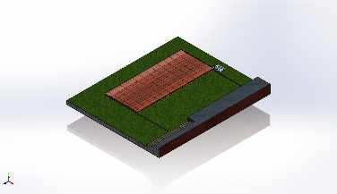 | Beam – Uniform C/S | Section Standard-weldment profiles/iso/square tube  Section Area: 0.000534796m^2  Length:420mm  Volume:0.000224615m^3  Mass Density:8,000kg/m^3  Mass:1.79692kg  Weight:17.6098N | D:\SWIMMING POOL ENCLOSER'S\SWIMMING POOL DECK\3D MODEL\POST HORIZANTAL TUBE.SLDPRT  Jun 10 17:09:11 2025
SolidBody 1(Cut-Extrude1)  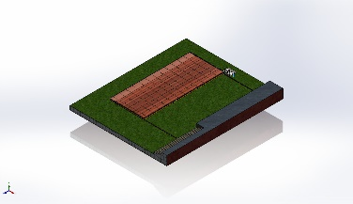 | Beam – Uniform C/S | Section Standard-weldment profiles/iso/square tube  Section Area: 0.000534796m^2  Length:216mm  Volume:0.000115516m^3  Mass Density:8,000kg/m^3  Mass:0.924128kg  Weight:9.05646N | D:\SWIMMING POOL ENCLOSER'S\SWIMMING POOL DECK\3D MODEL\POST VERTICAL TUBE.SLDPRT  Jun 10 17:08:53 2025
SolidBody 1(Cut-Extrude1) | Beam – Uniform C/S | Section Standard-weldment profiles/iso/square tube  Section Area: 0.000534796m^2  Length:216mm  Volume:0.000115516m^3  Mass Density:8,000kg/m^3  Mass:0.924128kg  Weight:9.05646N | D:\SWIMMING POOL ENCLOSER'S\SWIMMING POOL DECK\3D MODEL\POST VERTICAL TUBE.SLDPRT  Jun 10 17:08:53 2025
SolidBody 1(Square tube 40 X 40 X 4(1)) | Beam – Uniform C/S | Section Standard-weldment profiles/iso/square tube  Section Area: 0.000534796m^2  Length:420mm  Volume:0.000224615m^3  Mass Density:8,000kg/m^3  Mass:1.79692kg  Weight:17.6098N | D:\SWIMMING POOL ENCLOSER'S\SWIMMING POOL DECK\3D MODEL\POST HORIZANTAL TUBE.SLDPRT  Jun 10 17:09:11 2025
SolidBody 1(Cut-Extrude1) | Beam – Uniform C/S | Section Standard-weldment profiles/iso/square tube  Section Area: 0.000534796m^2  Length:216mm  Volume:0.000115516m^3  Mass Density:8,000kg/m^3  Mass:0.924128kg  Weight:9.05646N | D:\SWIMMING POOL ENCLOSER'S\SWIMMING POOL DECK\3D MODEL\POST VERTICAL TUBE.SLDPRT  Jun 10 17:08:53 2025
SolidBody 1(Cut-Extrude1) | Beam – Uniform C/S | Section Standard-weldment profiles/iso/square tube  Section Area: 0.000534796m^2  Length:216mm  Volume:0.000115516m^3  Mass Density:8,000kg/m^3  Mass:0.924128kg  Weight:9.05646N | D:\SWIMMING POOL ENCLOSER'S\SWIMMING POOL DECK\3D MODEL\POST VERTICAL TUBE.SLDPRT  Jun 10 17:08:53 2025
SolidBody 1(Sb beam 100 X 8(1))  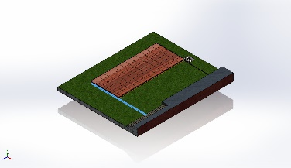 | Beam – Uniform C/S | Section Standard-weldment profiles/iso/sb beam  Section Area: 0.00109003m^2  Length:5,130mm  Volume:0.00559186m^3  Mass Density:8,000kg/m^3  Mass:44.7349kg  Weight:438.402N | D:\SWIMMING POOL ENCLOSER'S\SWIMMING POOL DECK\3D MODEL\SB I_CHANNEL 100 X 50 X 8.SLDPRT  Jun 9 10:31:29 2025
SolidBody 1(Sb beam 100 X 8(1)) | Beam – Uniform C/S | Section Standard-weldment profiles/iso/sb beam  Section Area: 0.00109003m^2  Length:5,130mm  Volume:0.00559186m^3  Mass Density:8,000kg/m^3  Mass:44.7349kg  Weight:438.402N | D:\SWIMMING POOL ENCLOSER'S\SWIMMING POOL DECK\3D MODEL\SB I_CHANNEL 100 X 50 X 8.SLDPRT  Jun 9 10:31:29 2025

Study Properties
Study name | Static 1
Analysis type | Static
Mesh type | Mixed Mesh
Thermal Effect: | On
Thermal option | Include temperature loads
Zero strain temperature | 298 Kelvin
Include fluid pressure effects from SOLIDWORKS Flow Simulation | Off
Solver type | Automatic
Inplane Effect: | Off
Soft Spring: | Off
Inertial Relief: | Off
Incompatible bonding options | Automatic
Large displacement | Off
Compute free body forces | On
Friction | Off
Use Adaptive Method: | Off
Result folder | SOLIDWORKS document (D:\SWIMMING POOL ENCLOSER'S\SWIMMING POOL DECK\3D MODEL)

Units
Unit system: | SI (MKS)
Length/Displacement | mm
Temperature | Kelvin
Angular velocity | Rad/sec
Pressure/Stress | N/m^2

Material Properties
Model Reference | Properties | Components
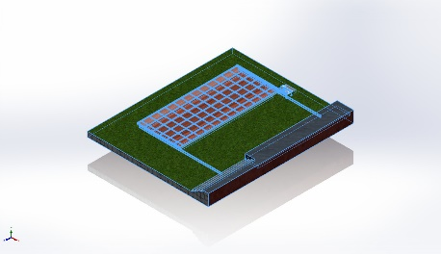 |  | SolidBody 1(Cut-Extrude11)(CIVIL BASE-1),  SolidBody 2(Boss-Extrude4)(CIVIL BASE-1),  SolidBody 1(Boss-Extrude1)(CLOSING SHEET 2-1),  SolidBody 1(Boss-Extrude1)(CLOSING SHEET 2-2),  SolidBody 1(Thread1)(PANEL ASM-1/BOTTOM WHEEL & BRACKET ASM-11/NUT-1),  SolidBody 1(Boss-Extrude1)(PANEL ASM-1/BOTTOM WHEEL & BRACKET ASM-11/WASHER-1),  SolidBody 1(Boss-Extrude1)(PANEL ASM-1/BOTTOM WHEEL & BRACKET ASM-11/WASHER-2),  SolidBody 1(Thread3)(PANEL ASM-1/BOTTOM WHEEL & BRACKET ASM-11/WHEEL AXLE-1),  SolidBody 1(Cut-Extrude1)(PANEL ASM-1/BOTTOM WHEEL & BRACKET ASM-11/WHEEL BRACKET 80 X 68 X 4 MM THK-1),  SolidBody 1(Cut-Extrude2)(PANEL ASM-1/BOTTOM WHEEL & BRACKET ASM-11/WHEEL-1),  SolidBody 1(p BEARING, SINGLE-ROW RADIAL, OPEN, METRIC 6200 SERIES — 6201 — 12mm ID × 32mm OD × 10mm W.STEP<1>[8])(PANEL ASM-1/BOTTOM WHEEL & BRACKET ASM-11/p BEARING, SINGLE-ROW RADIAL, OPEN, METRIC 6200 SERIES — 6201 — 12mm ID × 32mm OD × 10mm W.step-1),  SolidBody 2(p BEARING, SINGLE-ROW RADIAL, OPEN, METRIC 6200 SERIES — 6201 — 12mm ID × 32mm OD × 10mm W.STEP<1>[12])(PANEL ASM-1/BOTTOM WHEEL & BRACKET ASM-11/p BEARING, SINGLE-ROW RADIAL, OPEN, METRIC 6200 SERIES — 6201 — 12mm ID × 32mm OD × 10mm W.step-1),  SolidBody 3(p BEARING, SINGLE-ROW RADIAL, OPEN, METRIC 6200 SERIES — 6201 — 12mm ID × 32mm OD × 10mm W.STEP<1>[1])(PANEL ASM-1/BOTTOM WHEEL & BRACKET ASM-11/p BEARING, SINGLE-ROW RADIAL, OPEN, METRIC 6200 SERIES — 6201 — 12mm ID × 32mm OD × 10mm W.step-1),  SolidBody 4(p BEARING, SINGLE-ROW RADIAL, OPEN, METRIC 6200 SERIES — 6201 — 12mm ID × 32mm OD × 10mm W.STEP<1>[6])(PANEL ASM-1/BOTTOM WHEEL & BRACKET ASM-11/p BEARING, SINGLE-ROW RADIAL, OPEN, METRIC 6200 SERIES — 6201 — 12mm ID × 32mm OD × 10mm W.step-1),  SolidBody 5(p BEARING, SINGLE-ROW RADIAL, OPEN, METRIC 6200 SERIES — 6201 — 12mm ID × 32mm OD × 10mm W.STEP<1>[3])(PANEL ASM-1/BOTTOM WHEEL & BRACKET ASM-11/p BEARING, SINGLE-ROW RADIAL, OPEN, METRIC 6200 SERIES — 6201 — 12mm ID × 32mm OD × 10mm W.step-1),  SolidBody 6(p BEARING, SINGLE-ROW RADIAL, OPEN, METRIC 6200 SERIES — 6201 — 12mm ID × 32mm OD × 10mm W.STEP<1>[7])(PANEL ASM-1/BOTTOM WHEEL & BRACKET ASM-11/p BEARING, SINGLE-ROW RADIAL, OPEN, METRIC 6200 SERIES — 6201 — 12mm ID × 32mm OD × 10mm W.step-1),  SolidBody 7(p BEARING, SINGLE-ROW RADIAL, OPEN, METRIC 6200 SERIES — 6201 — 12mm ID × 32mm OD × 10mm W.STEP<1>[11])(PANEL ASM-1/BOTTOM WHEEL & BRACKET ASM-11/p BEARING, SINGLE-ROW RADIAL, OPEN, METRIC 6200 SERIES — 6201 — 12mm ID × 32mm OD × 10mm W.step-1),  SolidBody 8(p BEARING, SINGLE-ROW RADIAL, OPEN, METRIC 6200 SERIES — 6201 — 12mm ID × 32mm OD × 10mm W.STEP<1>[5])(PANEL ASM-1/BOTTOM WHEEL & BRACKET ASM-11/p BEARING, SINGLE-ROW RADIAL, OPEN, METRIC 6200 SERIES — 6201 — 12mm ID × 32mm OD × 10mm W.step-1),  SolidBody 9(p BEARING, SINGLE-ROW RADIAL, OPEN, METRIC 6200 SERIES — 6201 — 12mm ID × 32mm OD × 10mm W.STEP<1>[2])(PANEL ASM-1/BOTTOM WHEEL & BRACKET ASM-11/p BEARING, SINGLE-ROW RADIAL, OPEN, METRIC 6200 SERIES — 6201 — 12mm ID × 32mm OD × 10mm W.step-1),  SolidBody 10(p BEARING, SINGLE-ROW RADIAL, OPEN, METRIC 6200 SERIES — 6201 — 12mm ID × 32mm OD × 10mm W.STEP<1>[9])(PANEL ASM-1/BOTTOM WHEEL & BRACKET ASM-11/p BEARING, SINGLE-ROW RADIAL, OPEN, METRIC 6200 SERIES — 6201 — 12mm ID × 32mm OD × 10mm W.step-1),  SolidBody 11(p BEARING, SINGLE-ROW RADIAL, OPEN, METRIC 6200 SERIES — 6201 — 12mm ID × 32mm OD × 10mm W.STEP<1>[13])(PANEL ASM-1/BOTTOM WHEEL & BRACKET ASM-11/p BEARING, SINGLE-ROW RADIAL, OPEN, METRIC 6200 SERIES — 6201 — 12mm ID × 32mm OD × 10mm W.step-1),  SolidBody 12(p BEARING, SINGLE-ROW RADIAL, OPEN, METRIC 6200 SERIES — 6201 — 12mm ID × 32mm OD × 10mm W.STEP<1>[10])(PANEL ASM-
  Name: | AISI 304
  Model type: | Linear Elastic Isotropic
  Default failure criterion: | Max von Mises Stress
  Yield strength: | 2.06807e+08 N/m^2
  Tensile strength: | 5.17017e+08 N/m^2
  Elastic modulus: | 1.9e+11 N/m^2
  Poisson's ratio: | 0.29
  Mass density: | 8,000 kg/m^3
  Shear modulus: | 7.5e+10 N/m^2
  Thermal expansion coefficient: | 1.8e-05 /Kelvin
Curve Data:N/A

Loads and Fixtures

Load name | Load Image | Load Details
Force-1 | 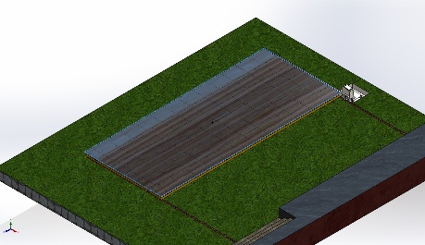
  Entities: | 1 face(s)
  Type: | Apply normal force
  Value: | 4,000 N

Connector Definitions
No Data

Interaction Information

Interaction | Interaction Image | Interaction Properties
Local Interaction-1 | 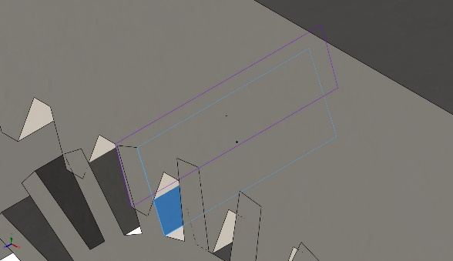
  Type: | Contact interaction pair
  Entities: | 2 face(s)
  Advanced: | Surface to surface
Local Interaction-2 | 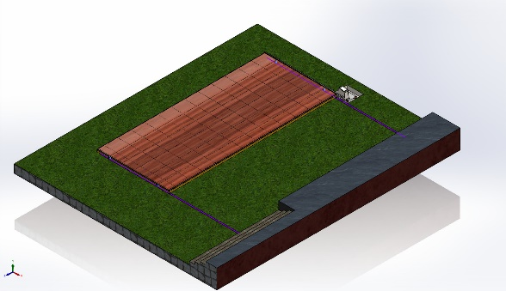
  Type: | Contact interaction pair
  Entities: | 6 face(s)
  Advanced: | Surface to surface
Global Interaction | 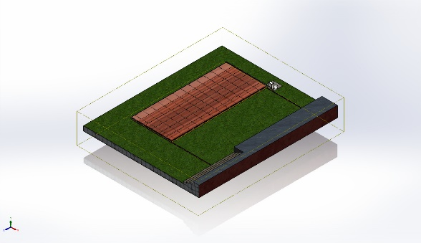
  Type: | Bonded
  Components: | 1 component(s)
  Options: | Independent mesh

Mesh information
Mesh type | Mixed Mesh
Mesher Used: | Blended curvature-based mesh
Jacobian points for High quality mesh | 16 Points
Jacobian check for shell | Off
Maximum element size | 607.14 mm
Minimum element size | 30.357 mm
Mesh Quality | High
Remesh failed parts independently | Off

Mesh information - Details
Total Nodes | 55060
Total Elements | 25588
Time to complete mesh(hh;mm;ss): | 01:00:18
Computer name:
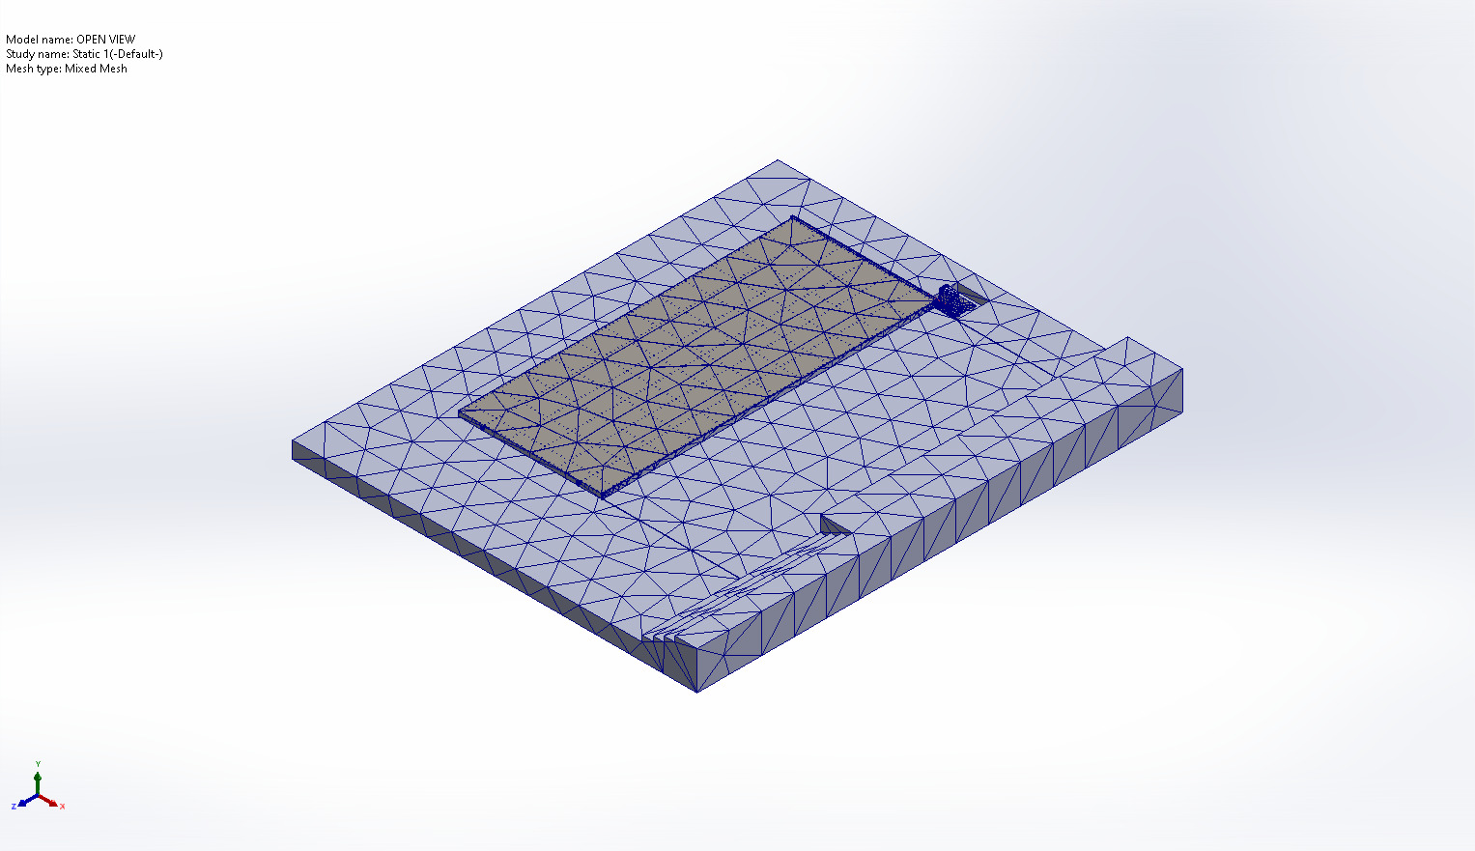

Sensor Details
No Data

Resultant Forces
No Data
No Data

Beams
No Data

Study Results
No Data

Conclusion

